FY2018 Milestone: Develop Experimental Severe Weather Outlook for Week 2
Climate Prediction Center
NOAA/NWS/NCEP

1. Goal and background
Developing week-2 severe weather outlooks is one of the CPC projects under the Office of Science and Technology Policy (OSTP) initiative. Recently, the NOAA Storm Prediction Center explored the use of the Supercell Composite Parameter (SCP) derived from the CFSv2 45-day forecast to provide extended-range severe weather environment guidance (Carbin et al. 2016). When SCP is greater than one, it is expected that severe weather will likely occur. As part of this project, we take one step further to forecast severe weather based on empirical relationship between model-predicted SCP and the observed severe weather in the historical record.
The overall goals of this project are:
- To develop forecast tools for week-2 sever weather, including tornadoes, hails, and damaging winds recorded by NWS Local Storm Reports (LSR3), and evaluate forecast skill; and
- To implement the forecast tools into operation at CPC for different time ranges, including week 2, days 8–10, 10–12, and 12–14. The forecast products will support the CPC’s Week-2 U.S. Hazards Outlook.

2. Results and accomplishments
The forecast model developed in this project is a hybrid dynamical-statistical model. It uses the dynamical model (GEFS and CFSv2) predicted SCP as a predictor, and then forecasts severe weather (LSR3) based on the statistical relationship between model SCP and observed LSR3 in historical record with a linear regression model. The forecast skill is cross-validated over the model hindcast period (1996–2012 for GEFS).
When applying the hybrid model to data at the 0.5º×0.5º grid for GEFS outputs, the forecasts suggest a low skill for week-2 severe weather (Fig. 1a). However, the forecast skill, and the outlook for LSR3 can be improved by using the 5º×5º area-averaged data (Fig. 1b). Averaging severe weather over a large area increases the spatial coherence for weekly LSR3 and enhances its relation to large-scale environmental conditions, and thus, increases the predictive skill of weekly severe weather.
From September 2018, we have started making experimental real-time forecast for week-2 severe weather in anticipation of transitioning the hybrid prediction system into operation. Figure 2 shows the web page designed for the real-time forecast for September 2018 with daily updates. For example, Figure 3 shows the week-2 severe weather forecast issued on September 24, 2018. The forecast consists of both 80-member ensemble mean prediction (left panel) and the probabilities for above-normal, near-normal, and below-normal weekly activities (right panels), respectively.
The forecast skill of the hybrid model depends on the strength of the statistical relationship between model predicted SCP and observed LSR3. The singular value decomposition (SVD) technique has been used to objectively identify the relationship between weekly SCP and LSR3. Figure 4 shows the spatial patterns of the three leading SVD modes with observational data (weekly CFSR SCP vs. LSR3) over MAM 1996–2012. Each mode displays a distinctive pattern (right) of LSR3 in consistent with the distribution of the SCP pattern (left). The three modes account for 62% of the weekly LSR3 variance.
The SVD analysis between GEFS week-2 SCP and observed LSR3 shows spatial patterns in each mode (Figure 5) similar to their counterparts in observations (Figure 4). The three leading patterns of the model SCP also account for 58% of the observed weekly LSR3 variance, comparable to the observations. The hybrid model based on the SVD-depicted SCP-LSR3 relationship shows higher forecast skills (Fig. 1c) than the simple linear regression model (Fig. 1b), especially in the eastern and central U.S. The SVD-based forecast model will be tested using the CFSv2 45-day hindcast data. This prediction system will also be implemented for real-time week-2 severe weather forecast in the next two months.

In summary, following milestone accomplishments are noted:
- The CFSv2 45-day hindcast dataset was downloaded from the NOAA HPSS. The hindcast data are being processed for developing CFSv2-based dynamical-statistical forecast model for week-2 severe weather and comparing with the GEFS-based hybrid forecast model.
- The GEFS-based hybrid model has been tested and implemented for experimental real-time week-2 severe weather forecast. The forecasts are updated daily, including both 80-member ensemble mean forecast and probability forecast.
- The forecast skill of the GEFS-based hybrid model has been further improved by using the statistical relationship between the model SCP and observed LSR3 depicted by the leading SVD modes.

3. Plan for FY19
- Establish real-time verification and forecast skill assessment for week-2 severe weather, and make a comparison between the CFSv2-based and GEFS-based dynamical-statistical forecast models.
- Explore the feasibility of forecasts for week 3–4 severe weather by using both the CFSv2 45-day hindcast and forecast, and extending the CFSv2-based hybrid week-2 forecast system to weeks 3 and 4.
- Develop similar hybrid forecast tools using dynamical forecasts from the North American Multi-Model Ensemble (NMME) models.

4. Publications and presentations
Wang, H., A. Diawara, A. Kumar, and D. DeWitt: Dynamical-statistical predictions of week-2 severe weather for the contiguous United States. In preparation, 2018.
Wang, H., A. Diawara, A. Kumar, and D. DeWitt: Developing an experimental week 2–4 severe weather outlook for the United States. The 42nd NOAA Climate Diagnostics and Prediction Workshop Special Issue, Climate Prediction S&T Digest, 38–41, 2018.
Diawara, A., H. Wang, A. Kumar, and D. DeWitt: Predictive capacity of week 3–4 severe weather outlook for the United States using CFSv2 45-day hindcast data. The 43rd NOAA Climate Diagnostics and Prediction Workshop, Santa Barbara, California, 23–25 October 2018.

Reference
Carbin, G. W., M. K. Tippett, S. P. Lillo, and H. E. Brooks, 2016: Visualizing long-range severe thunderstorm environment guidance from CFSv2. Bull. Amer. Meteor. Soc., 97, 1021–1032.

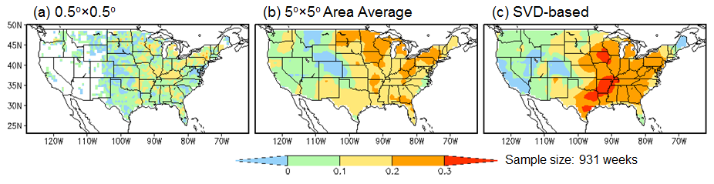
Figure 1. Forecast skill (anomaly correlation) of the GEFS-based hybrid model for week-2 severe weather based on cross-validations over MAM 1996–2012, the GEFS hindcast period. The anomaly correlations are shown for (a) simple linear regression model at the 0.5º×0.5º model data grid, (b) simple linear regression model with 5º×5º area-averaged data, and (c) SVD-based hybrid forecast model.

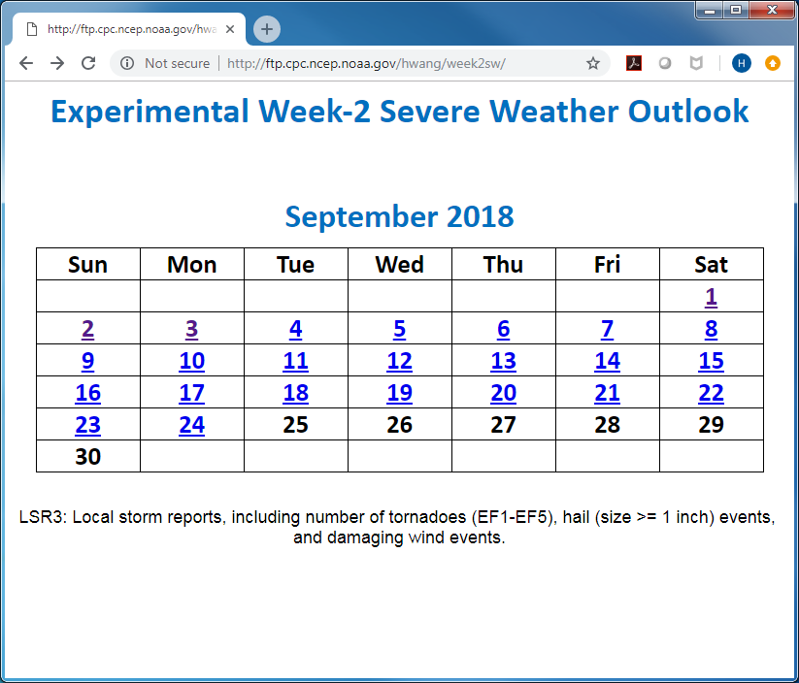

Figure 2. Web page (http://ftp.cpc.ncep.noaa.gov/hwang/week2sw/) of experimental real-time forecasts of week-2 severe weather over the U.S. The forecasts are updated daily around 11:00 AM Eastern Time.

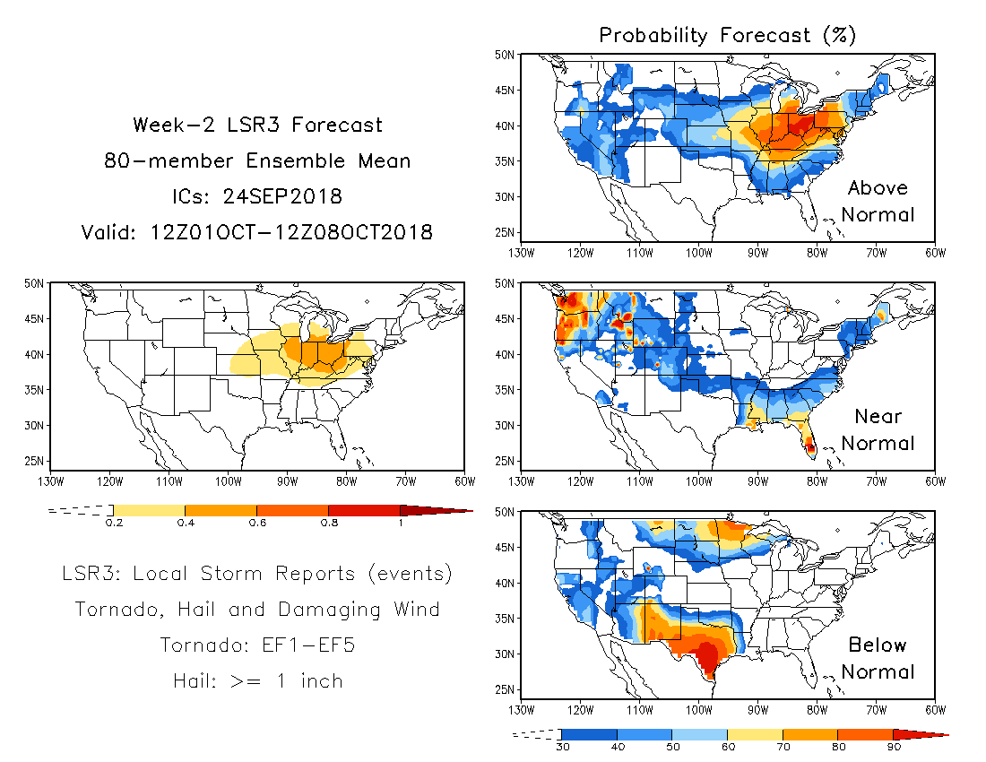

Figure 3. Example of real-time week-2 severe weather forecasts issued on September 24, 2018 for the week of October 1, 12Z to October 8, 12Z. Left panel is the 80-member ensemble mean forecast. Right panels are the probability forecast with chances of above-normal (top), near-normal (middle), and below-normal (bottom) severe weather, respectively.

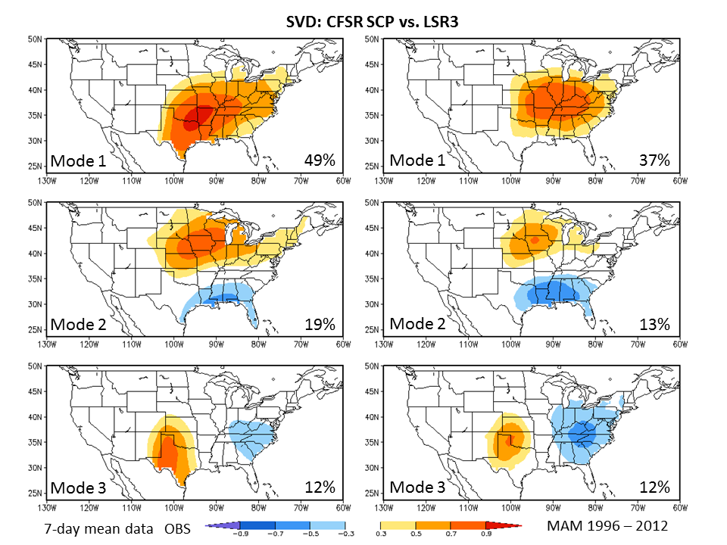
Figure 4. Homogeneous correlation maps of three leading SVD modes between weekly CFSR SCP (left) and observed weekly LSR3 (right) over MAM 1996–2012.

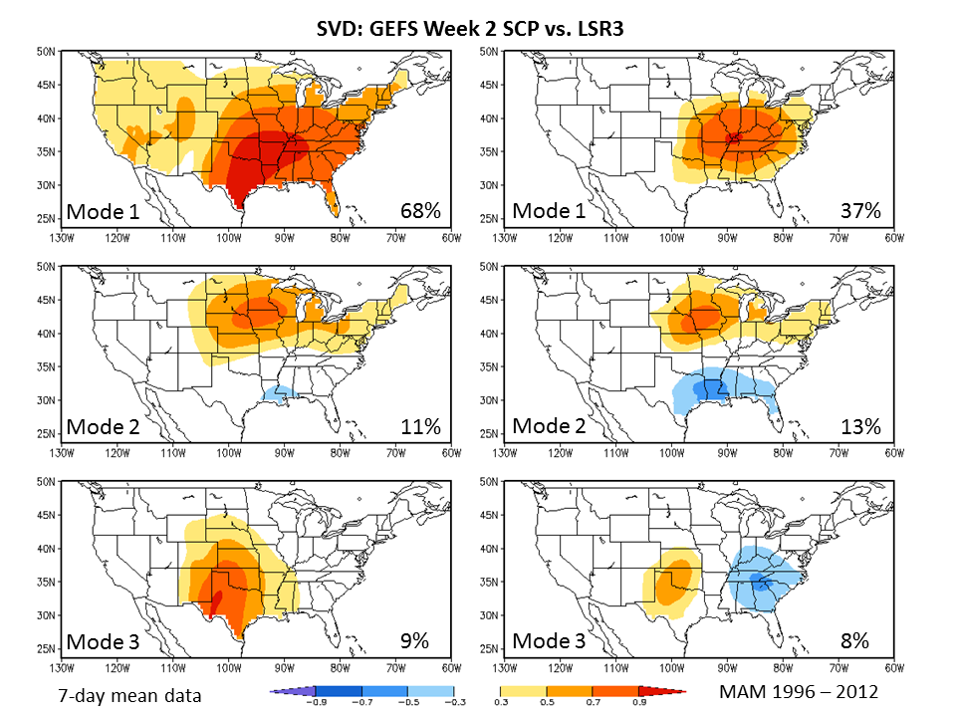
Figure 5. Homogeneous correlation maps of three leading SVD modes between GEFS predicted week-2 SCP (left) and observed weekly LSR3 (right) over MAM 1996–2012.

