Report on the “Development of Experimental Severe Weather Outlook for Weeks 2 to 4”
28 July 2017
Hui Wang, Alima Diwara, Arun Kumar
Climate Prediction Center

- Goal
  - Develop experimental severe weather outlooks for Weeks 3-4
  - As a first step, assess capability of GEFS in predicting severe weather (SW) on week 2 time-scale as a first step towards developing a prediction capability for severe weather outlooks for Weeks 3-4
  - Based on earlier peer reviewed research (Carbin et al. 2016), Supercell Composite Parameter (SCP), which is a function of convective available potential Energy (CAPE), strong deep-layer vertical wind shear, or bulk wind difference (BWD), and storm potential energy (SRH), was selected as the large scale controlling factor for the local storm report (LSR). Storm Prediction Center (SPC) has a database of LSR that includes tornado, hail and strong damaging winds and is the target for prediction. LSR is taken as the proxy for severe weather, and the target for prediction.
  - The initial approach for assessing a predictive capability for severe weather outlook:
    - Analyze relationship between SCP in observations (with CFSR as the proxy for the observed SCP) and LSR; LSR database if from 1955 - 2016.
    - Analysis how well SCP is predicted in GEFS. GEFS hindcast database is from 1996-2012 and is the analysis period.
    - Analyze relationship between GEFS predicted SCP and observed LSR and use this relationship in the prediction mode , i.e., from the GFES predicted value of SCR, infer expected value of LSR
    - GEFS hindcasts are to day 16, and therefore, potential for forecast capability on this time scale can be analyzed.
- Analysis Sequence
  - Characteristics of SCP and LSR in observations. SCP in the CFSR
    - Spatial climatology of SCP and its seasonality
    - Spatial climatology of LSR and its seasonality
    - Relationship between observed SCP and LSR
      - Visual inspection of relationship between seasonal climatology of SCP and LSR, e.g., are they collocated?
      - What is the interannual variability in SCP and LSR in observations?
      - Are there threshold values of SCP above which LSR is more likely?
      - What is the local relationship? An approach to analyze this is anomaly correlation over all events. One could also try anomaly correlation between SCP and LSR for a cutoff value of SCP (events below which are not included in the computation of AC)
  - GEFS prediction of SCP
    - Spatial climatology of SCP and its seasonality for GEFS forecasts and lead time dependence.
    - What is skill for SCP in GEFS predictions?
  - Relationship between predicted GEFS SCP and observed LSR based on hindcasts. This relationship becomes the basis for real-time prediction or the basis of dynamical-empirical prediction
- Preliminary conclusions (based on the analysis so far)
  - The GEFS forecast skill for week-2 SCP is low. This is to be expected as we are trying to predict something on scale even finer than precipitation, prediction skill for which is also low.
  - The correlation between the GEFS predicted week-2 SCP and observed LSR is very weak.
  - Therefore, the forecast skill of week-2 severe weather (LSR) based on GEFS predicted week-2 SCP is also low.
  - As skill will go down further with lead time, skill for weeks 3 &4 based on CFSv2 will be lower.
- Future plans
  - The correlation between GEFS predicted SCP and observed LSR is higher when first averaging anomalies over a 5º×5º (or 10º×10º) box instead of using anomalies at 0.5º×0.5º grid point.
  - This indicates that the forecast skill, at the expense of spatial resolution, could be increased for LSR averaged over a larger area.
  - We will try removing the “damaging wind” from the forecast as its seasonality in the eastern US is different from that of SCP.
  - Following the analysis sequence we have developed, repeat the same analysis using CFSv2 predicted SCP for longer lead-time forecasts
  - It is possible that SCP may not be the best predictor for LSR. We could search for different predictors, but at this time, starting point is not well defined.

Analysis of climatology and variability in SCP and LSR and their seasonality

Characteristics of SCP and LSR in observations
- Spatial climatology of SCP and its seasonality based on the CFSR

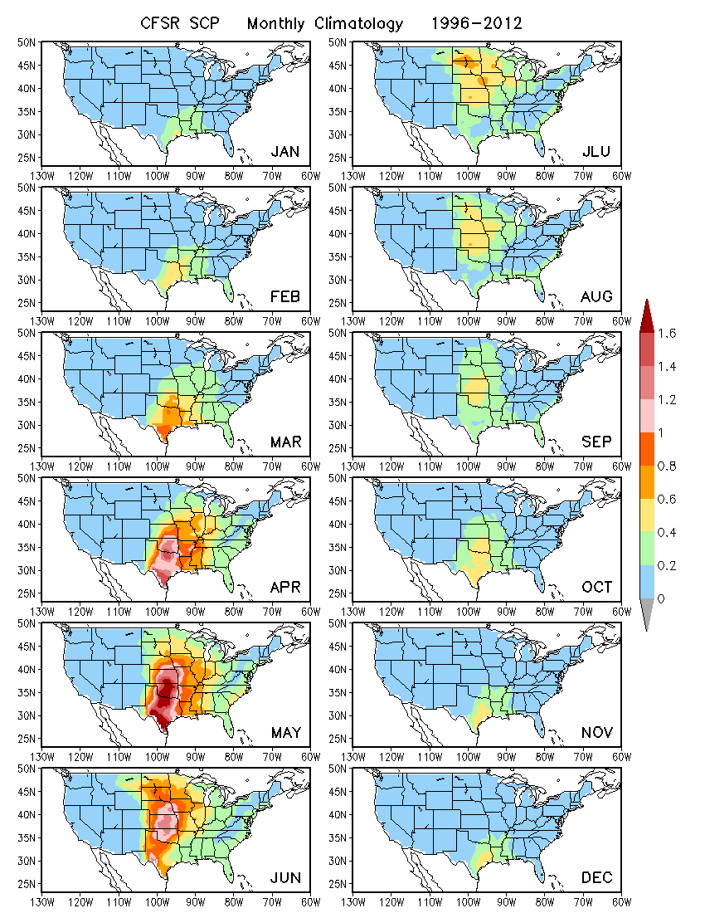

Spatial climatology of LSR3 and its seasonality (LSR3: Hail + Tornado + Wind). Observational data base is from SPC

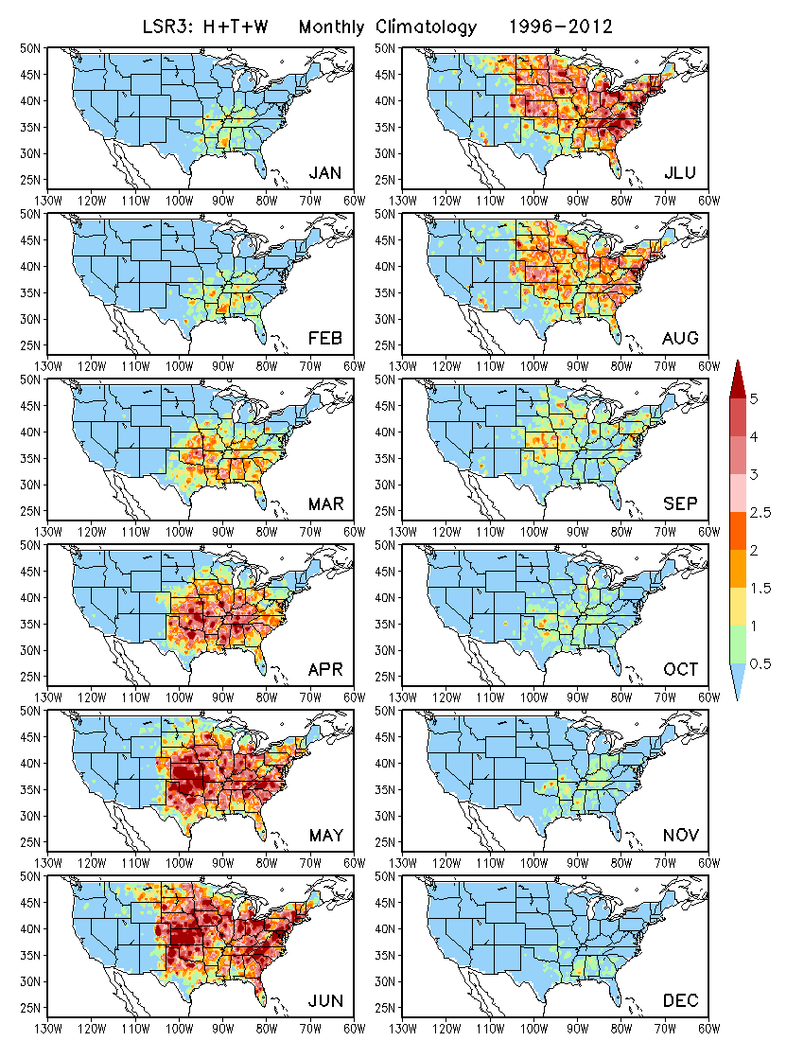

The seasonality different from SCP in the eastern US. The seasonality in the spatial pattern of LSR does not match well with the seasonality of SCP (LSR has more eastward extension). This is due to the inclusion of wind events in the definition of LSR.

Spatial climatology of Hail and its seasonality

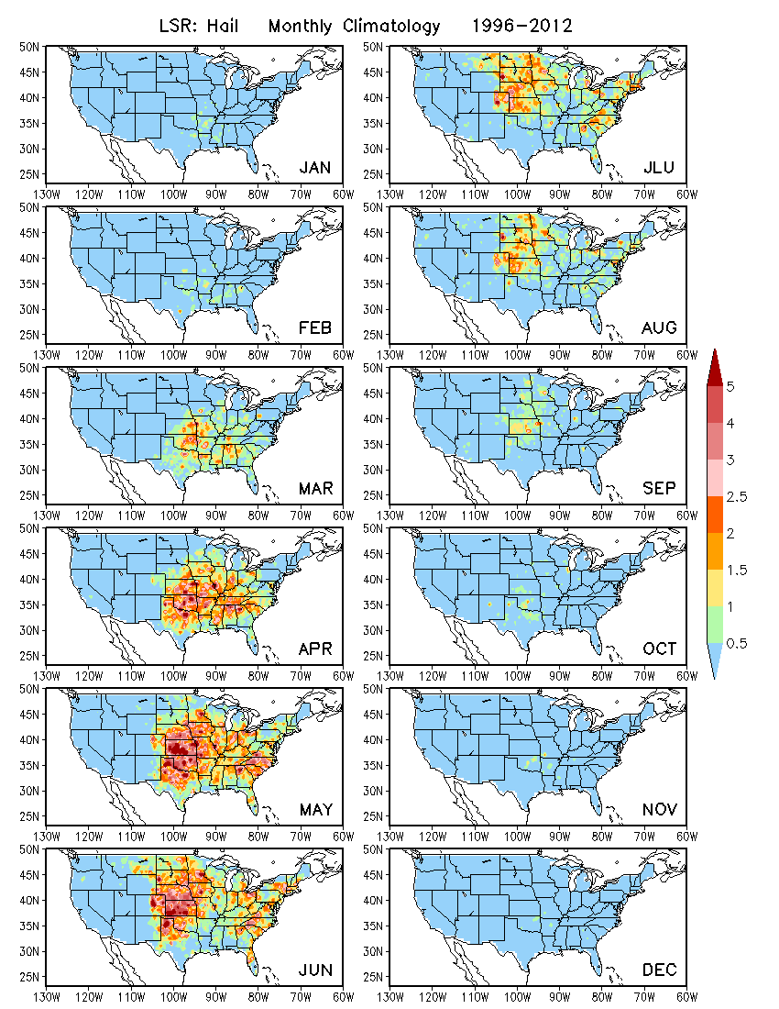

Spatial climatology of Tornado and its seasonality
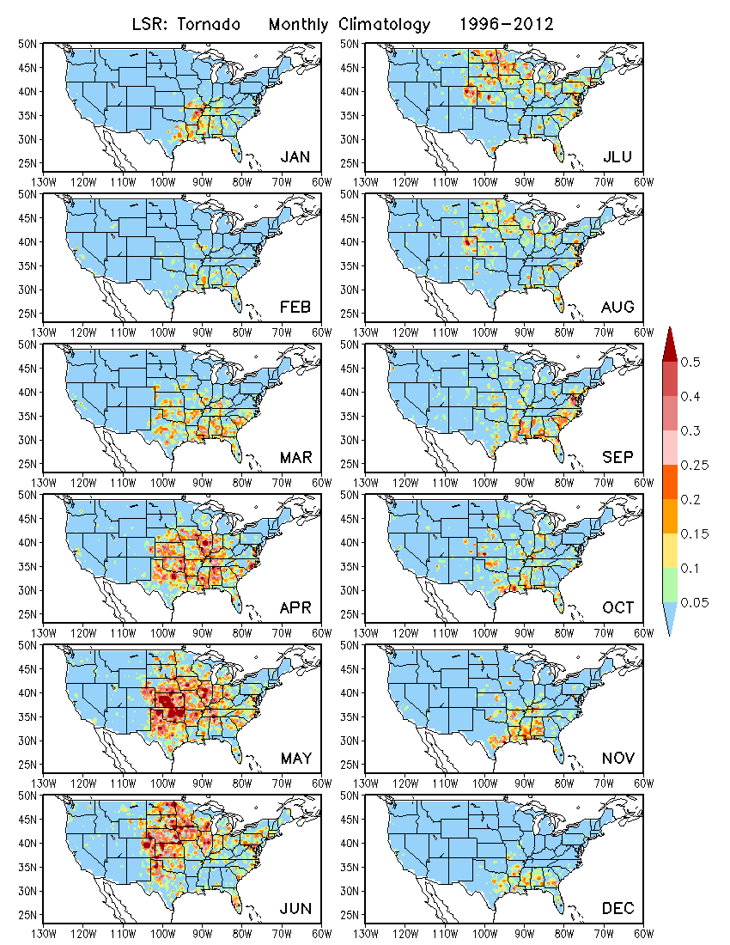

Spatial climatology of Wind and its seasonality

Weak in the central Plains and the Midwest, but strong in the east during April–August.

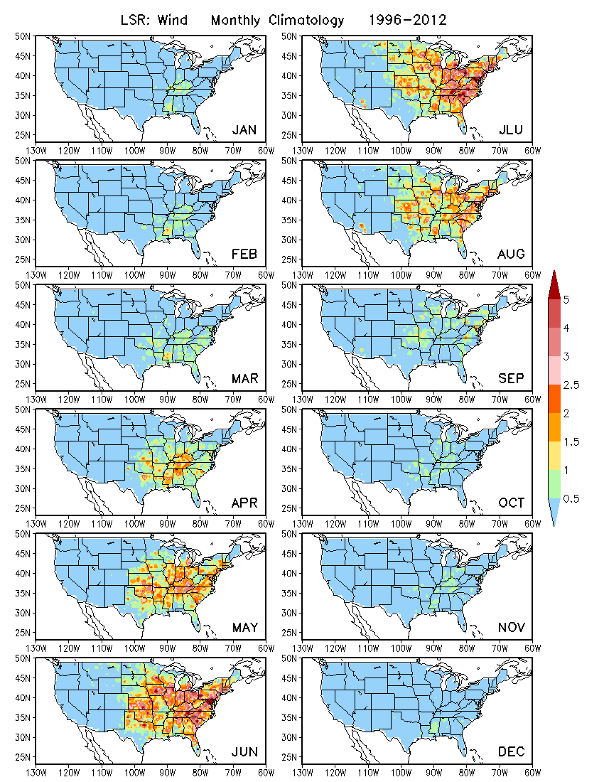

Standard deviation of CFSR SCP and LSR (hail, tornado, wind) for daily mean anomalies

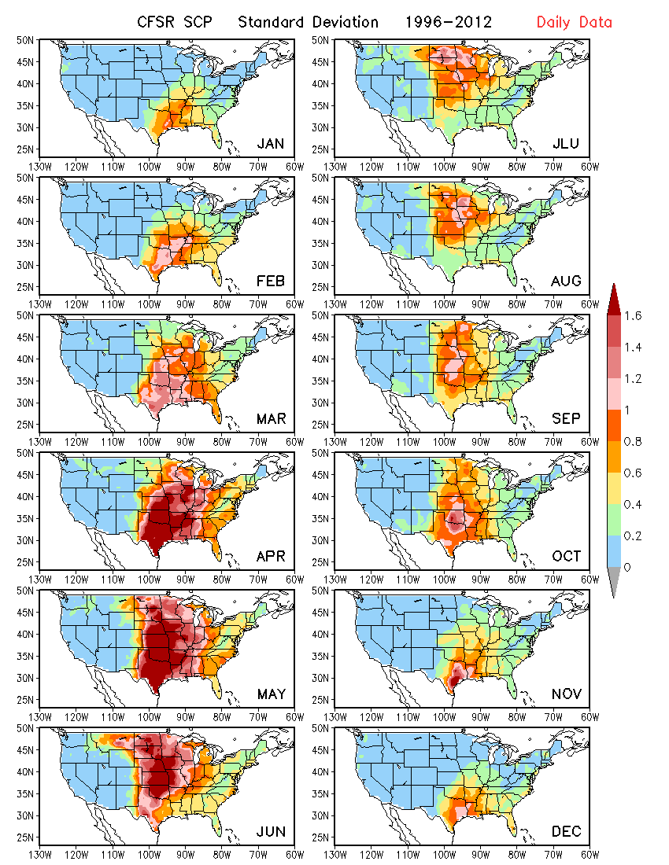

Hail

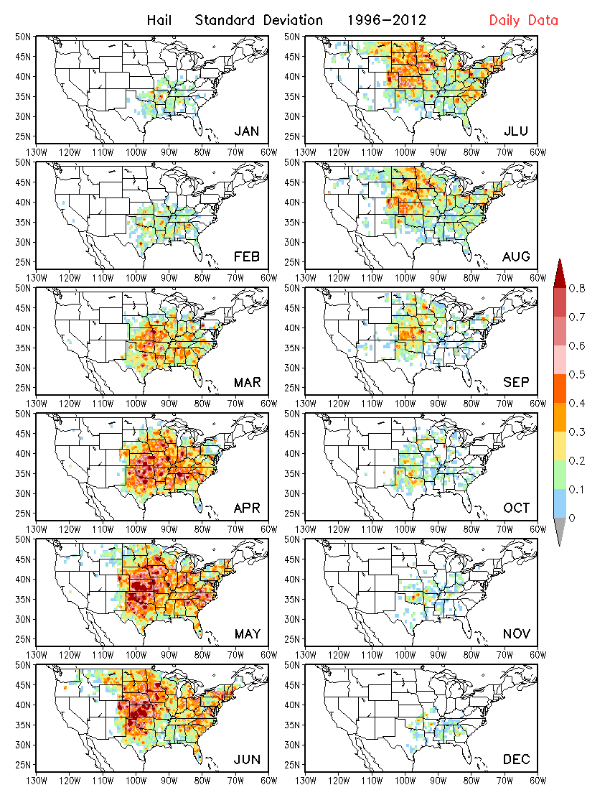

Tornado
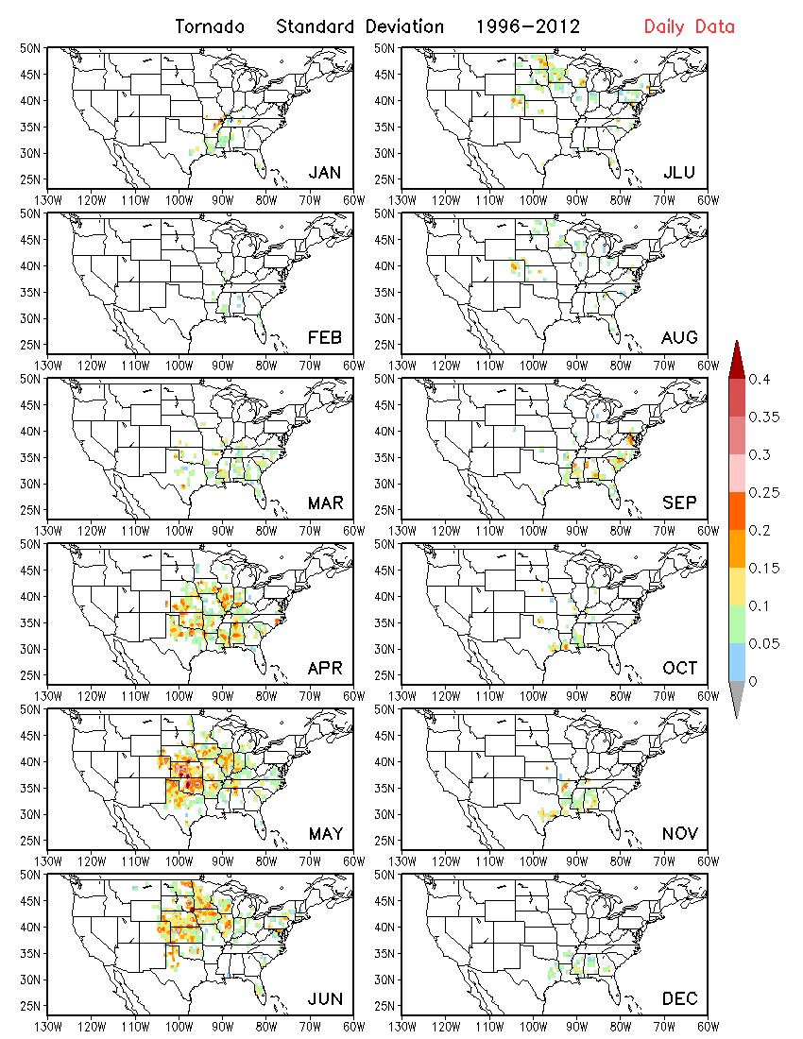

Wind

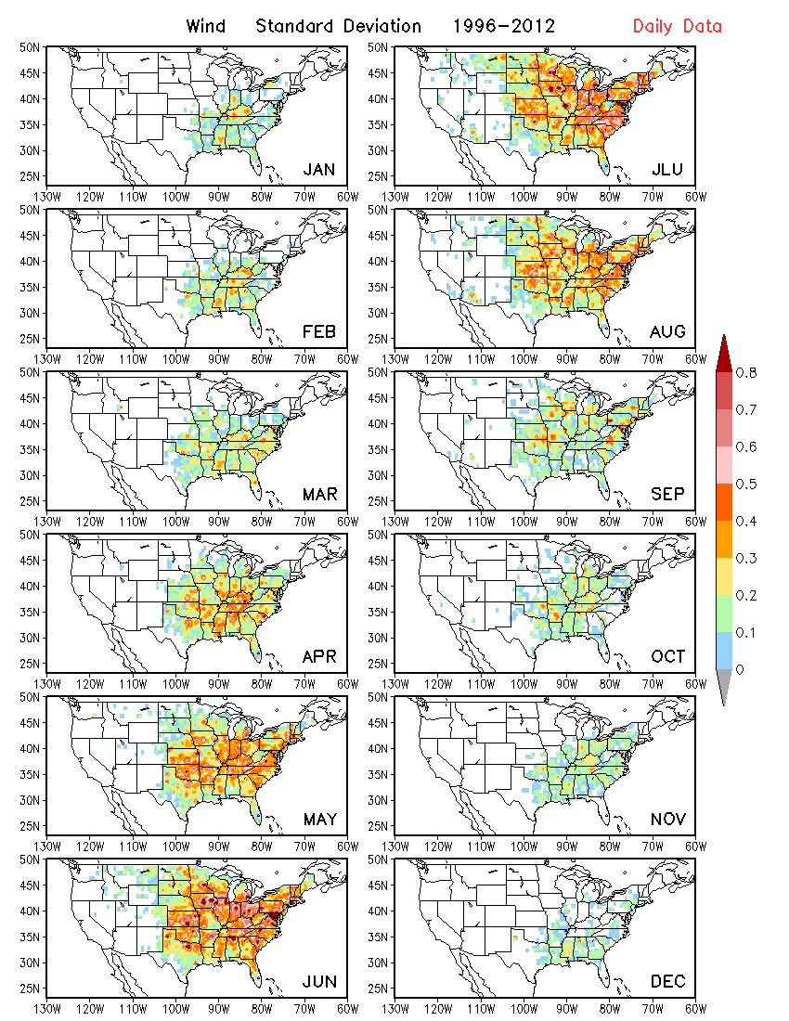

CFSR variability in SCP for weekly mean anomalies

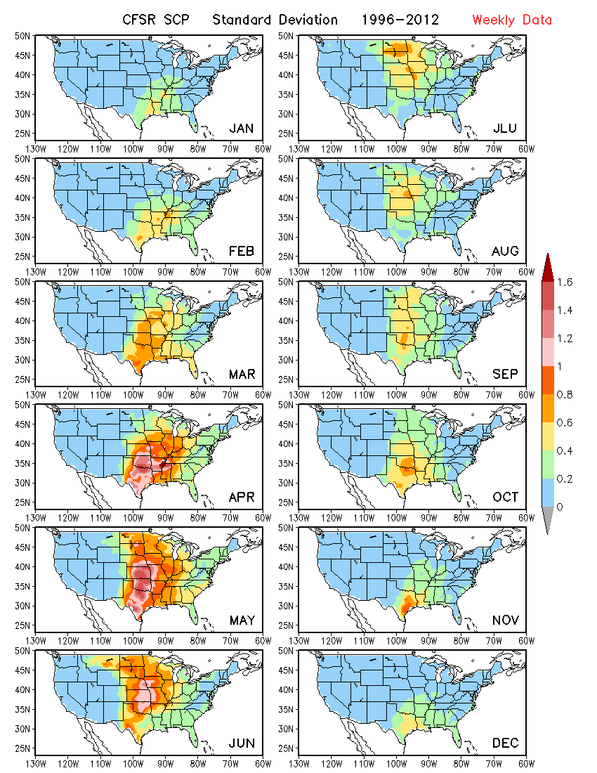

Hail (Weekly mean data)

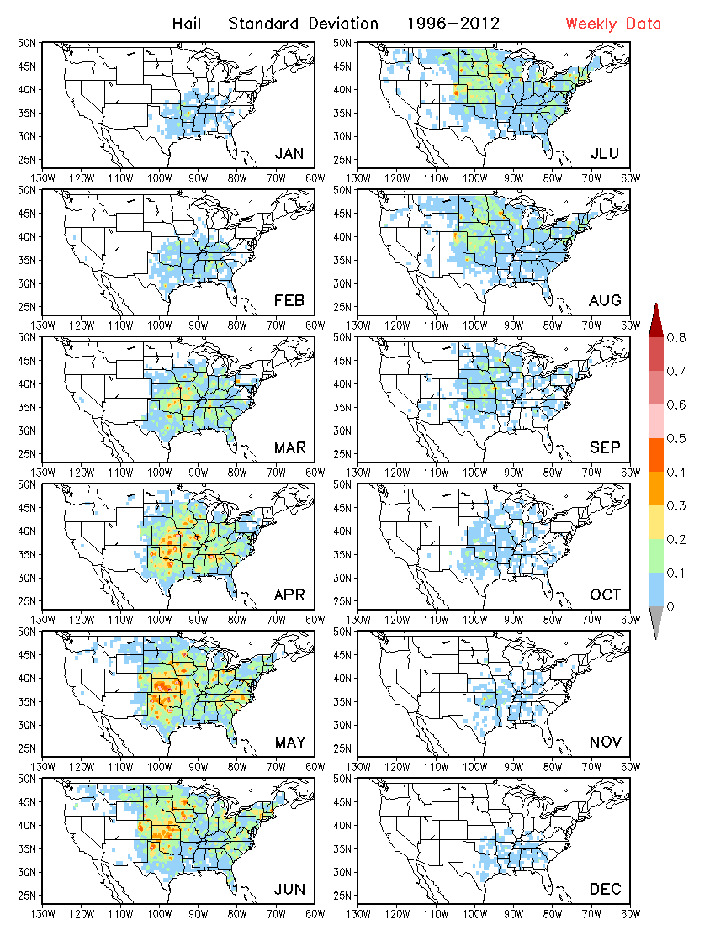

Tornado (Weekly mean data)

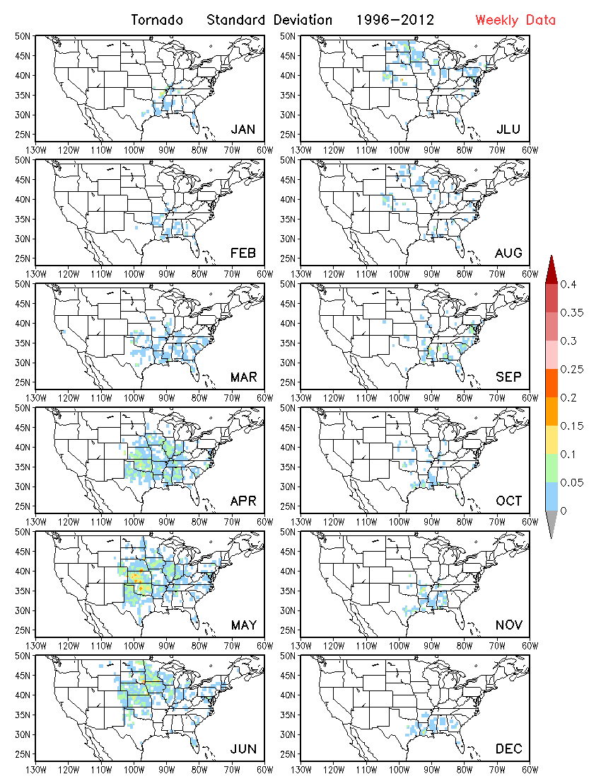

Wind (Weekly mean data)

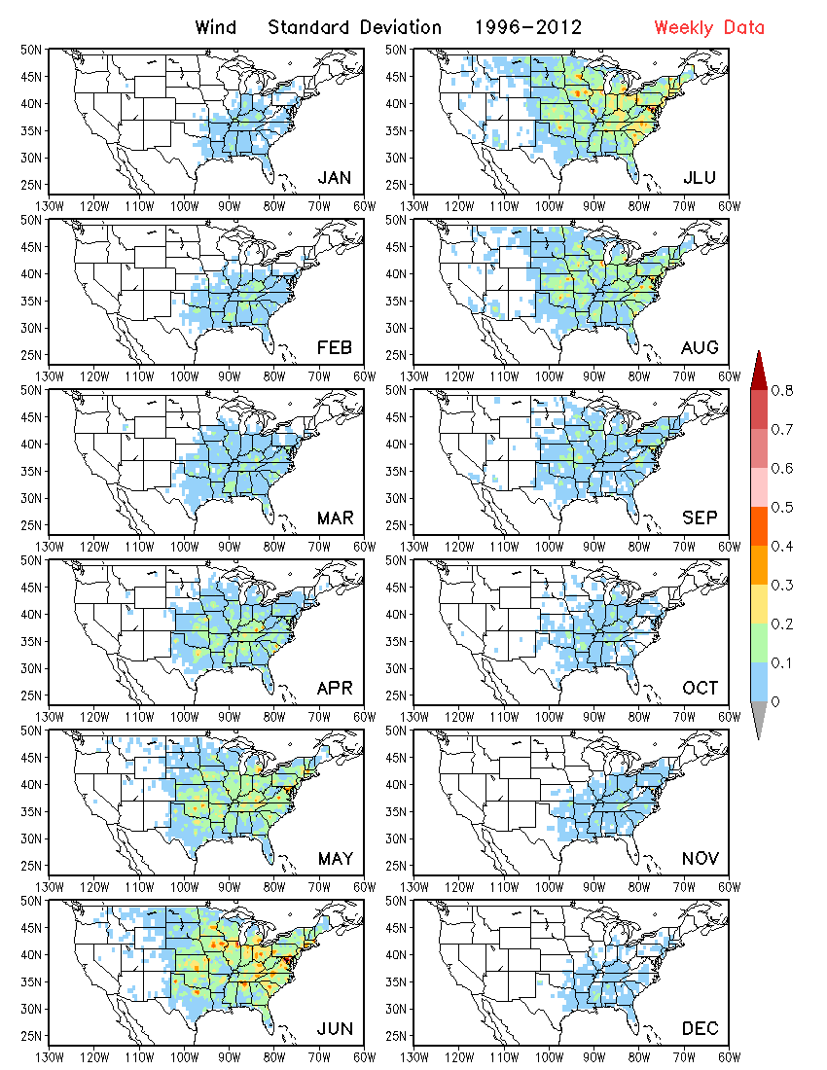

Relationship between observed SCP and LSR (both for climatology and interannual variability)
- Selected domain to be examined: 90ºW–100ºW, 35ºN–45ºN

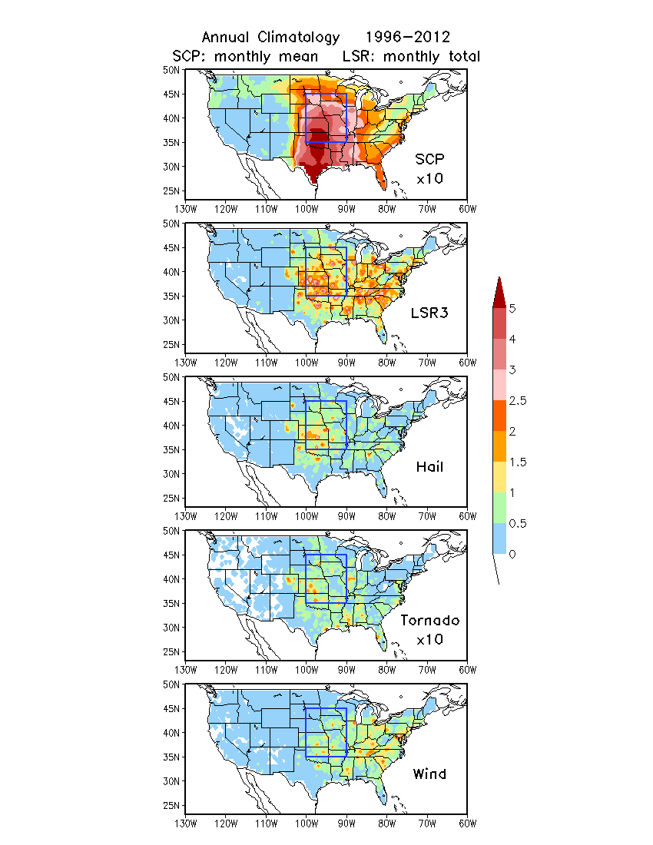

Daily climatology data

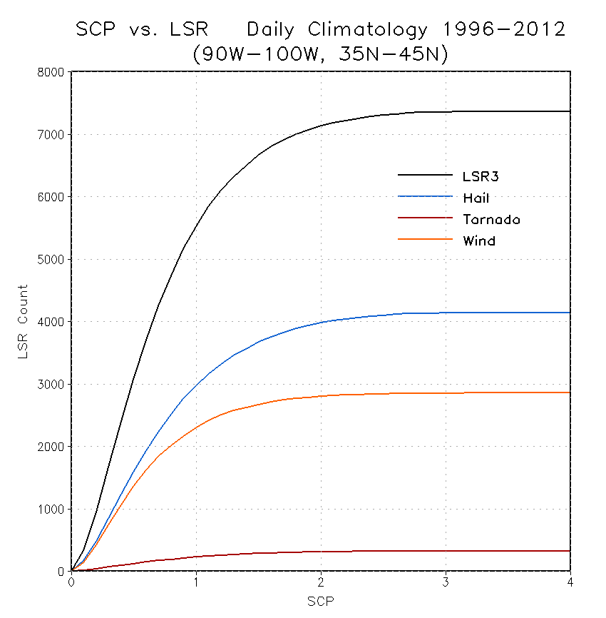
LSR counts over grids (90ºW–100ºW, 35ºN–45ºN) when SCP < x-axis value.

As the SCP value increases, the number of LSR also increases. It seems that there exists a linear relationship between LSR and SCP when SCP is between 0 and 1. A threshold value is not indicated.

17-year daily data

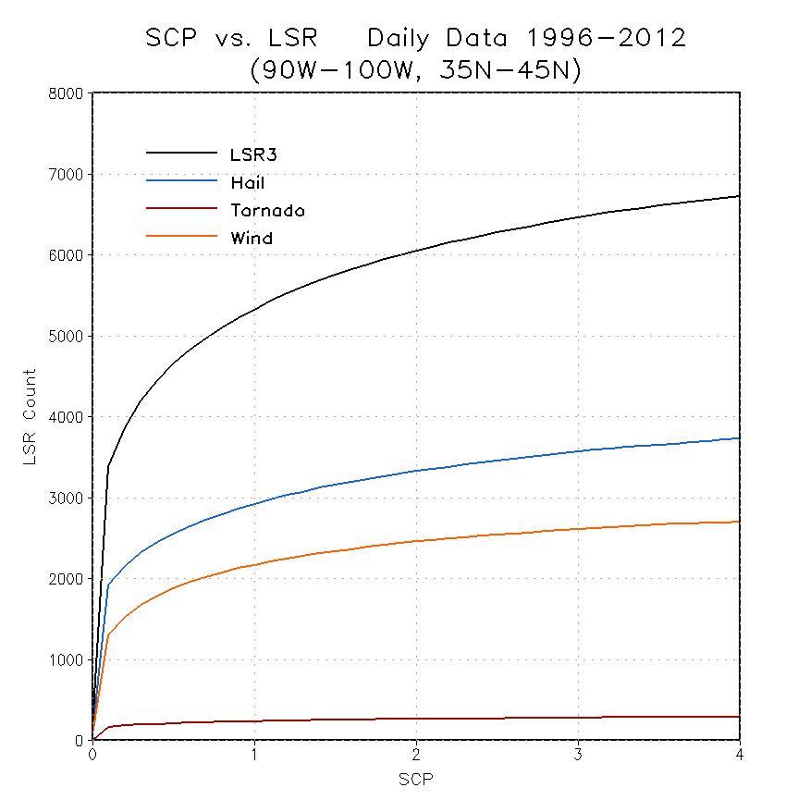
LSR counts over grids (90ºW–100ºW, 35ºN–45ºN) when SCP < x-axis value
When exploring the relationship between the value of SCP and the occurrence of LSR with daily data, it is found that a certain number of severe weather events are insensitive to the value of SCP. Therefore, it is hard to discern a threshold value of SCP for the occurrence of LSR.

Analysis of Prediction Skill for GEFS

GEFS prediction of SCP (against SCP in the CFSR taken as the verification)
- Spatial climatology and its seasonality for GEFS forecasts (Day-1 forecast)

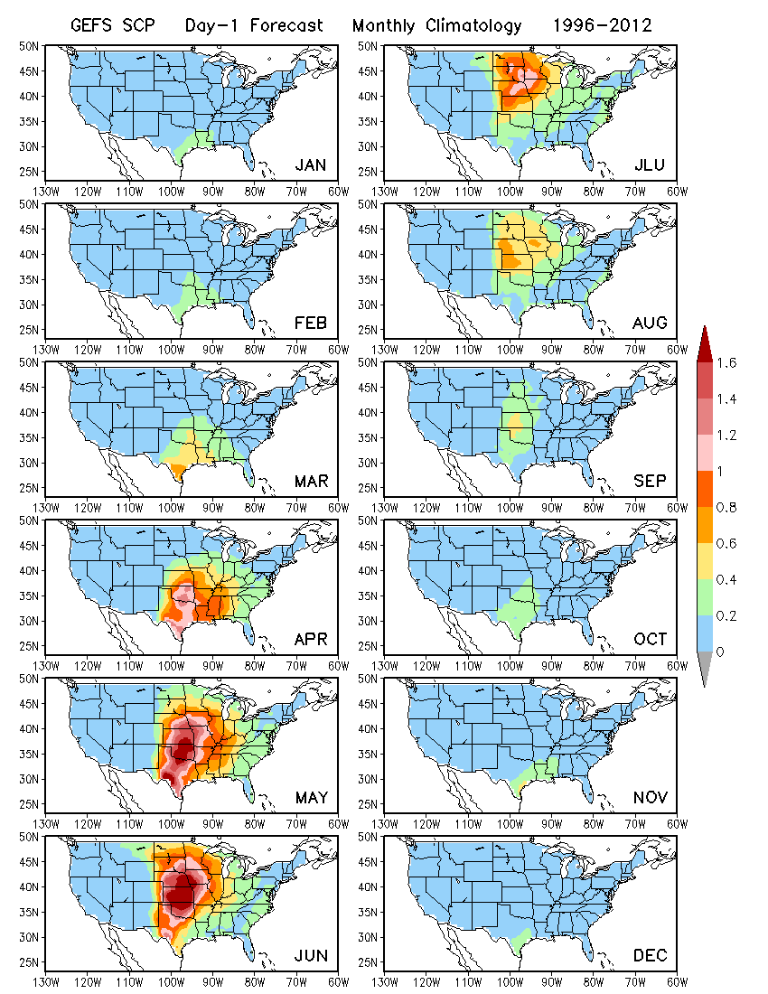

Spatial climatology and its seasonality for GEFS forecasts (Day-8 forecast)

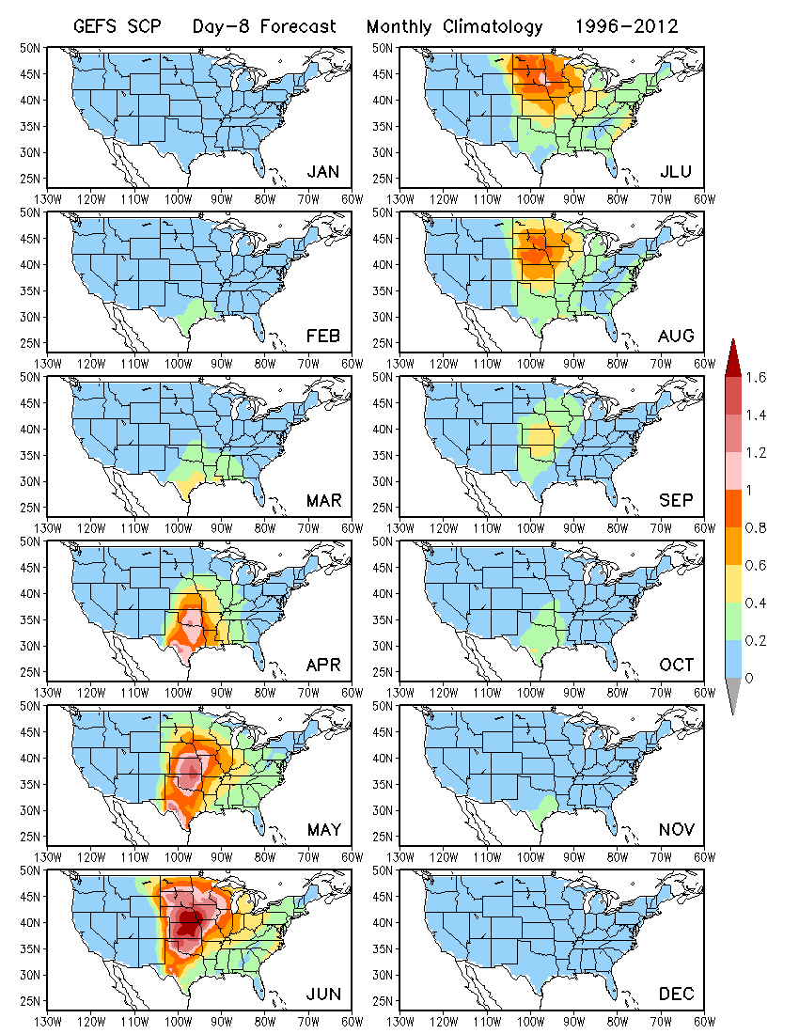

Spatial climatology and its seasonality for GEFS forecasts (Day-14 forecast)

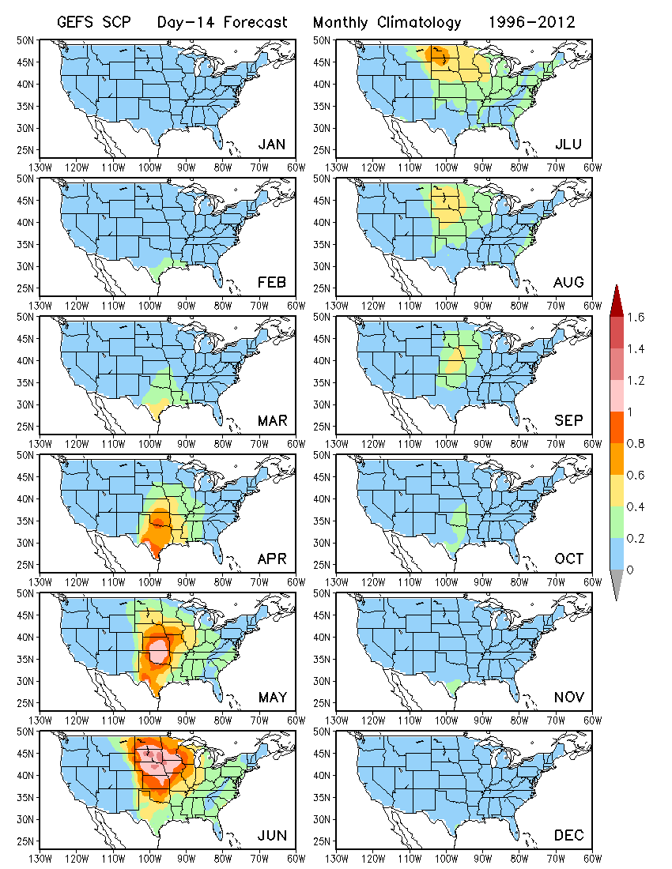

Spatial climatology for GEFS forecasts and lead time dependence (May SCP, Day 1 to day 12)

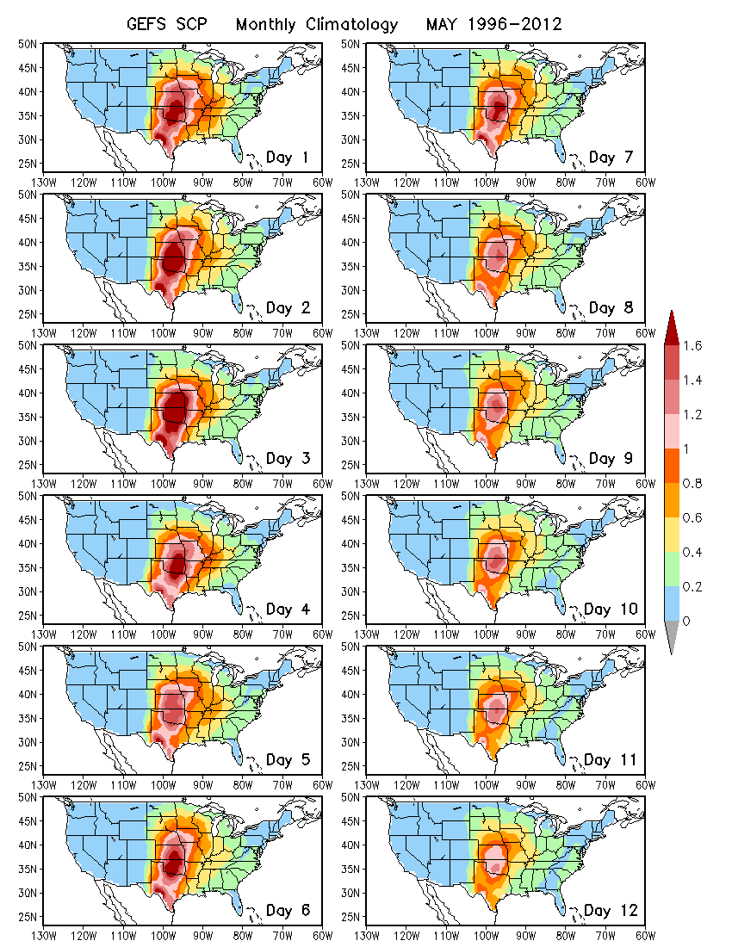
Difference in spatial pattern with lead time indicates evolution of model bias.

GEFS prediction of SCP
- What is skill for SCP in GEFS predictions? (Anomaly correlation for Day 1 to Day 12)

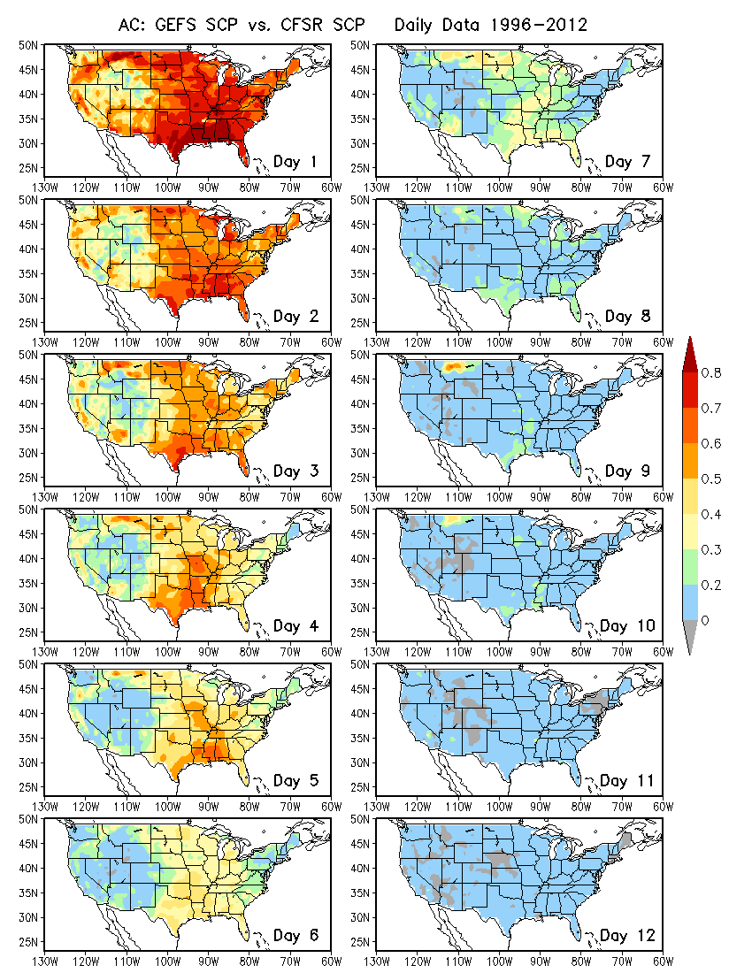
A sharp decline in the prediction skill of SCP with lead time.

GEFS prediction of SCP
- What is skill for SCP in GEFS predictions?
(Anomaly correlation for Week-1 and Week-2 forecasts)

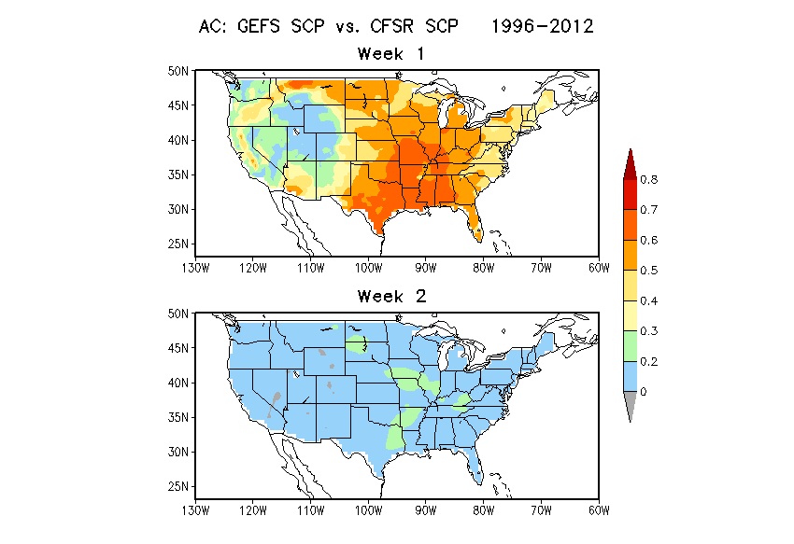

Skill in predicting Week2 average of SCP by GEFS is very low.

Relationship between predicted GEFS SCP and observed LSR based on GEFS hindcasts. This relationship becomes the basis for real-time prediction or the basis of dynamical-empirical prediction. Week 1 for LSR3 (3-month windows)
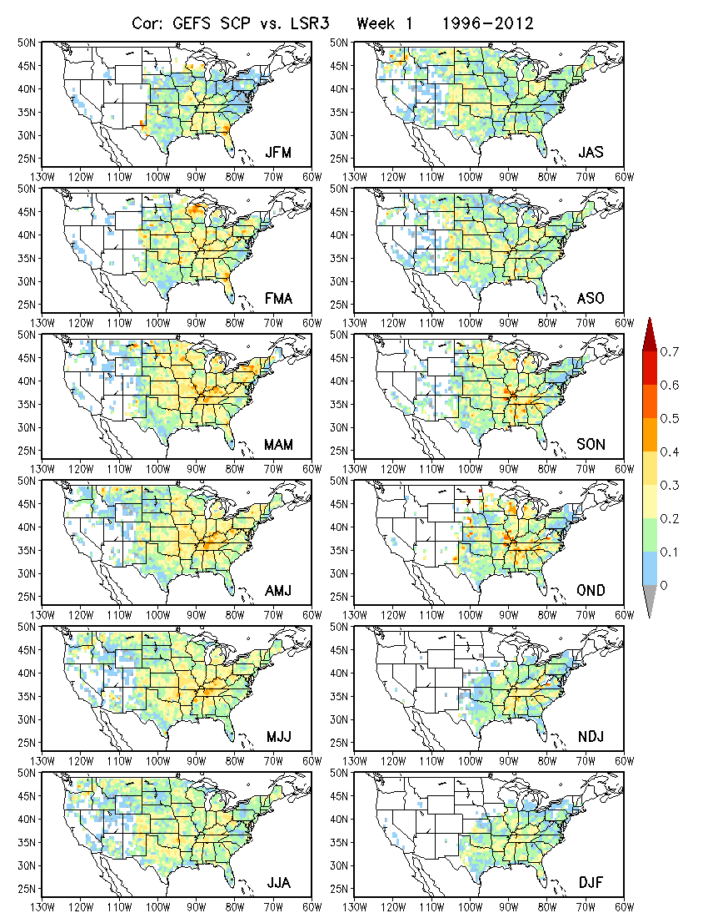

Week 2 for LSR3 (3-month windows)
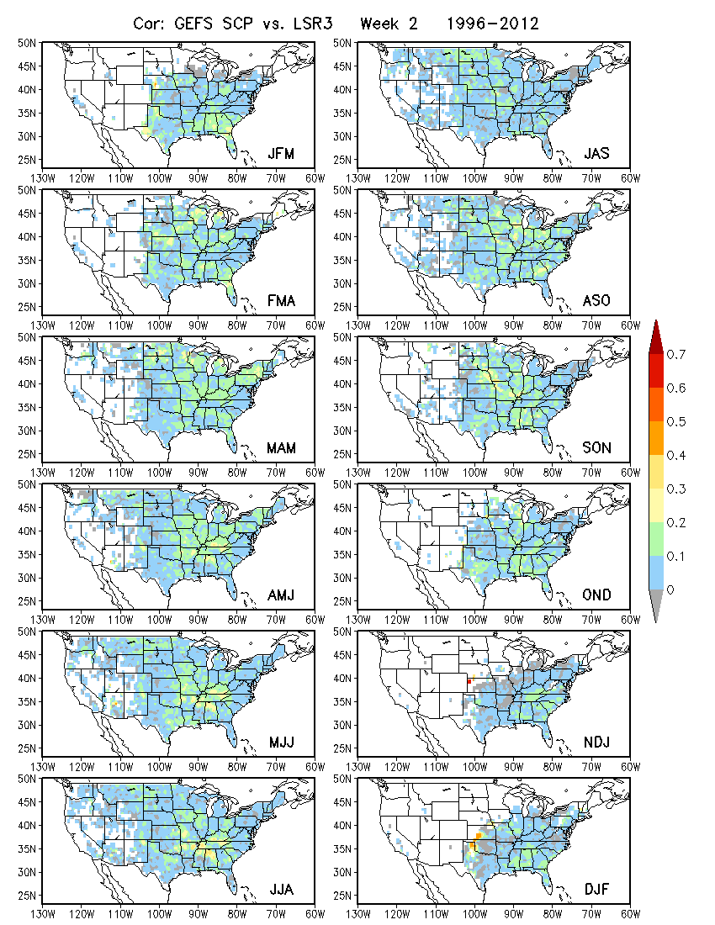

Similar correlation maps between GEFS predicted SCP and observed LSR3 but both anomalies are averaged over a 10º×10º box centered at each grid point prior to calculating correlations.
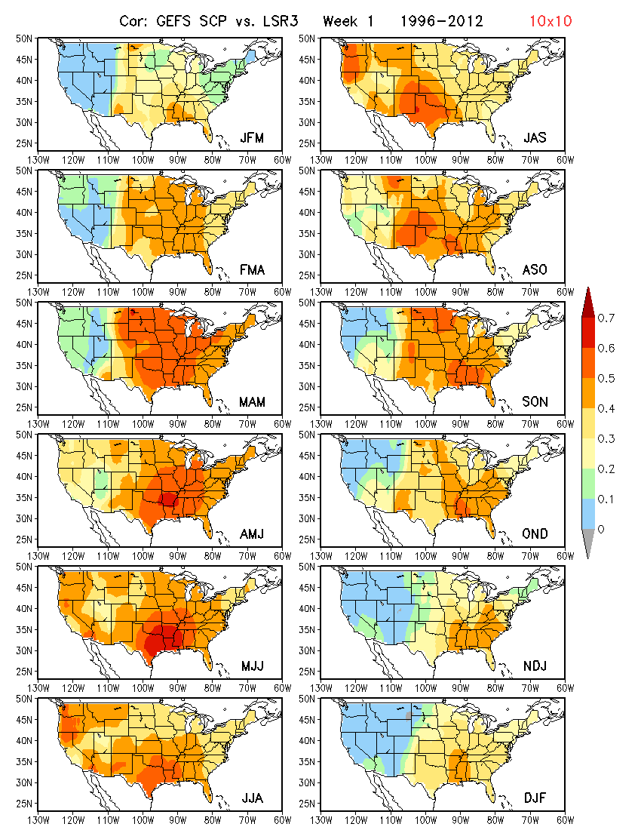

Correlation maps for Week 2. It is likely that the forecast skill for LSR3 over 10º×10º box areas can be higher than for 0.5º×0.5º grid point.
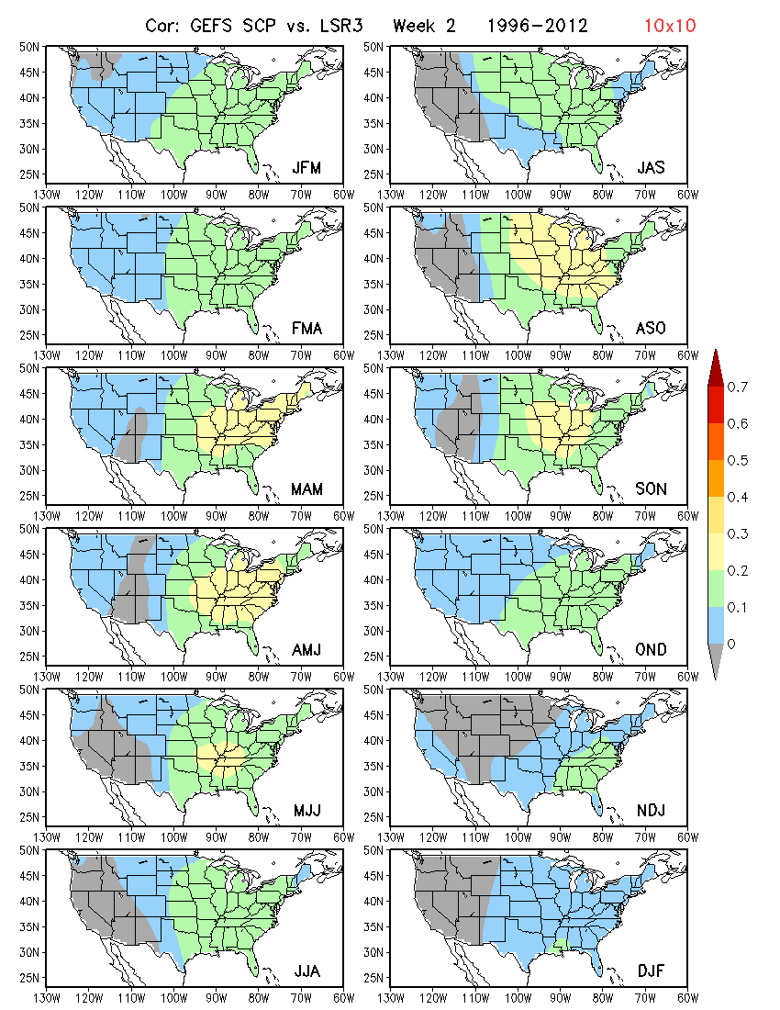

Similar results for 5º×5º box area-averaged anomalies.
Week 1

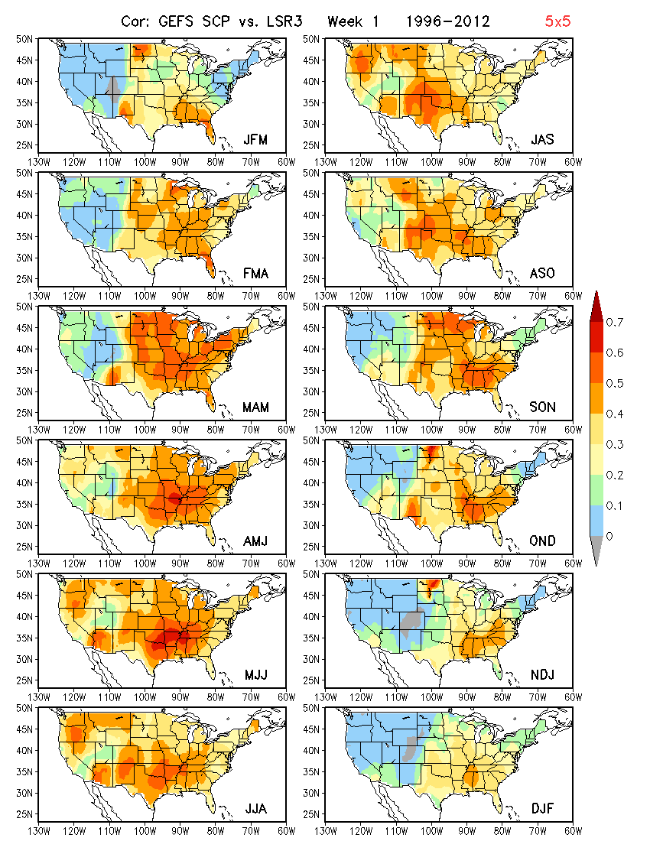

Week 2, using 5o×5o box area-averaged anomalies

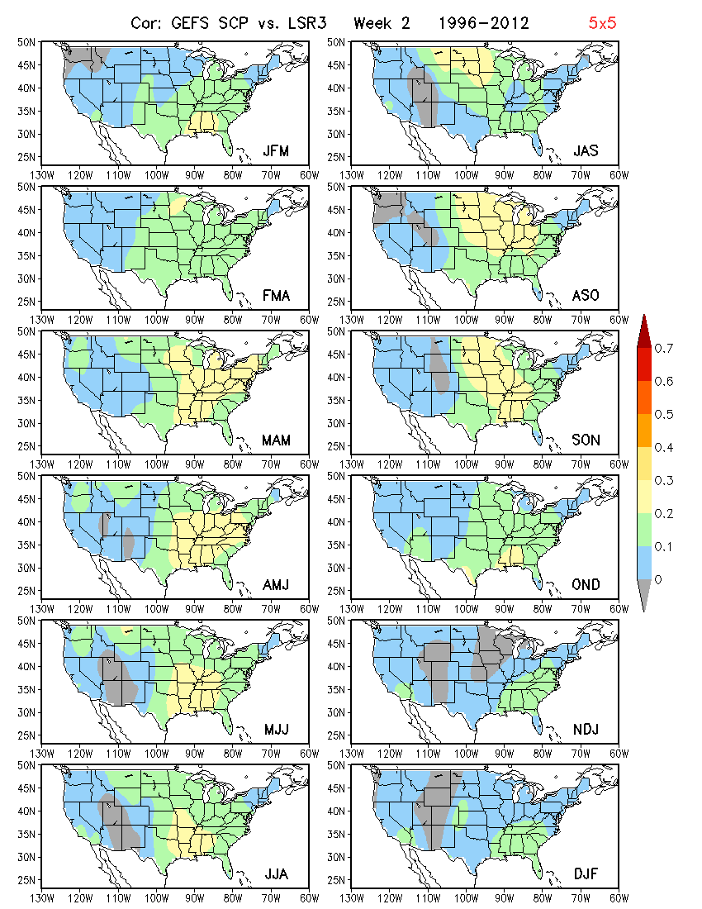

Correlations of GEFS SCP with SR3, hail, tornado and wind, respectively, for
MAM, Week1 (left) and Week 2 (right)

The correlation between predicted SCP and LSR3 (hail + tornado + wind) is slightly stronger than individual types of LSR.

Because of the weak correlation between GEFS predicted week-2 SCP and observed LSR, it is expected that the forecast skill for LSR based on week-2 SCP is going to be low.

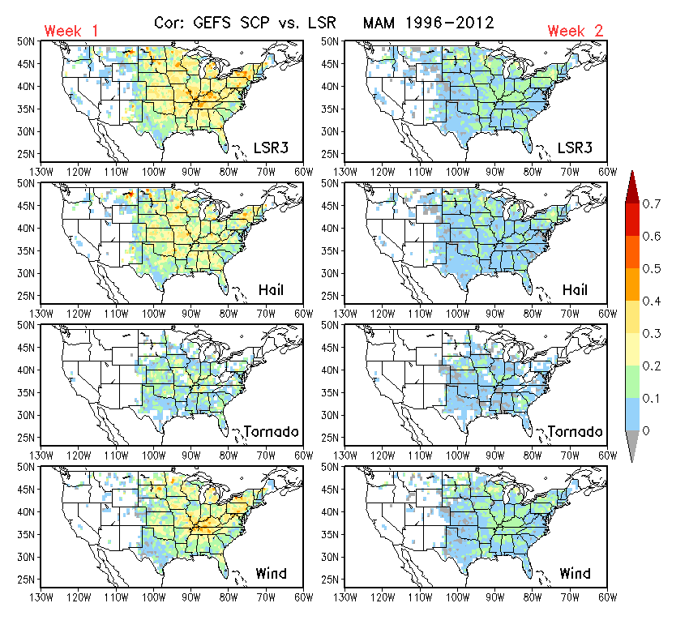

Hybrid dynamical-statistical prediction of MAM LSR3

Forecast skill assessed based cross-validation over the GEFS hindcast period (1996–2012)
- Anomaly correlation (left)
- Hit rate (right; 3 categories, 33%, 33%, 33%)

The anomaly correlation skill is low for week 2 LSR forecasts, which is consistent with the weak relationship between GEFS predicted week-2 SCP and observed LSR.

