WEATHER CLIMATE WATER

GLOBAL SEASONAL
CLIMATE UPDATE
Pre-Operational Phase
TARGET SEASON: July-August-September 2020

Issued: 22 June 2020
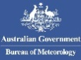

Summary
Observed sea surface temperatures anomalies in the east-central topical Pacific were in a neutral El Niño condition during March-April-May 2020. The Indian Ocean Dipole (IOD) was also in a near neutral conditions. The sea surface temperatures in the Niño 3.4 and Niño 3 regions, both of which are often used to characterize ENSO conditions, are predicted in a near-average range during July-August-September 2020.
Influences from the expected tendency towards positive sea surface temperature anomalies across sizeable portions of the globe, both in the tropics (except for below-normal conditions in the central and eastern Pacific) and extra-tropics, are seen in the temperature forecast for July-September 2020, which leans towards above-normal land temperature, particularly at tropical latitudes. The near-average sea surface conditions predicted in much of the eastern equatorial Pacific may noticeably affect the overlying tropical atmospheric circulation and climate, as they participate in the SST gradients with positive SST anomalies in the western Pacific. A global warming trend also contributes to the sea surface temperature and air temperature forecast, leading to a general prevalence of increased chances of above-average temperatures compared to a climatological base period (1993–2009) that is centred nearly 20 years in the past.
Below-average precipitation conditions are expected in the equatorial Pacific east of 150ºE, and an enhanced probability for above normal precipitation is expected just north of the equator in the eastern tropical Pacific, the central and western Indonesian Archipelago, and southern equatorial Indian Ocean. Some tilts of the odds for precipitation are likely associated with equatorial sea surface temperature anomalies and their east-west gradient in the equatorial Pacific, such as the above-average precipitation in much of the Indonesian Archipelago. An enhanced probability for below-normal precipitation is predicted for the tropical western and southernmost parts of Africa, Europe, and southern parts of South America. A shift of the odds towards above-normal precipitation is predicted for northern South America, Australia, and Indian subcontinent.

Surface Air Temperature, JAS 2020  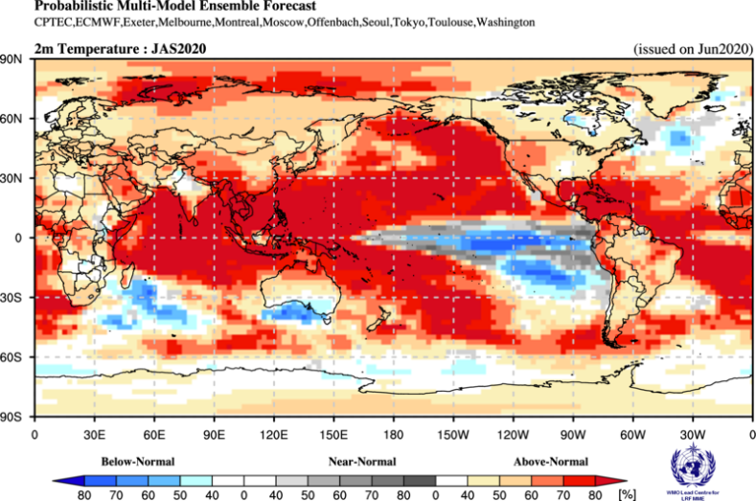 | Precipitation, JAS 2020  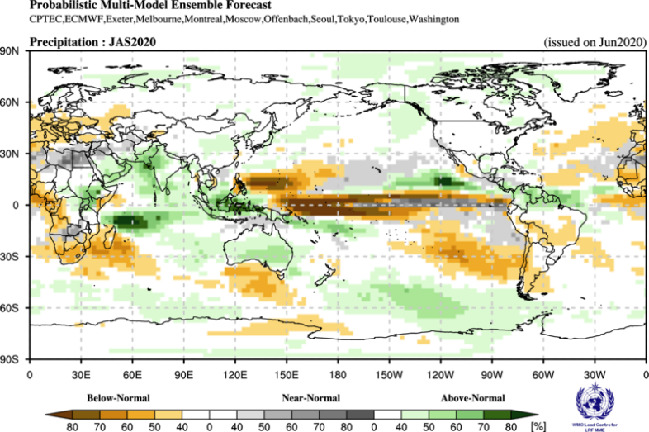

Figure 1. Probabilistic forecasts of surface air temperature and precipitation for the season May-June-July 2020. The tercile category with the highest forecast probability is indicated by shaded areas. The most likely category for below-normal, above-normal and near-normal is depicted in blue, red and grey shadings respectively for temperature, and orange, green and grey shadings respectively for precipitation. White areas indicate equal chances for all categories in both cases. The baseline period is 1993–2009.

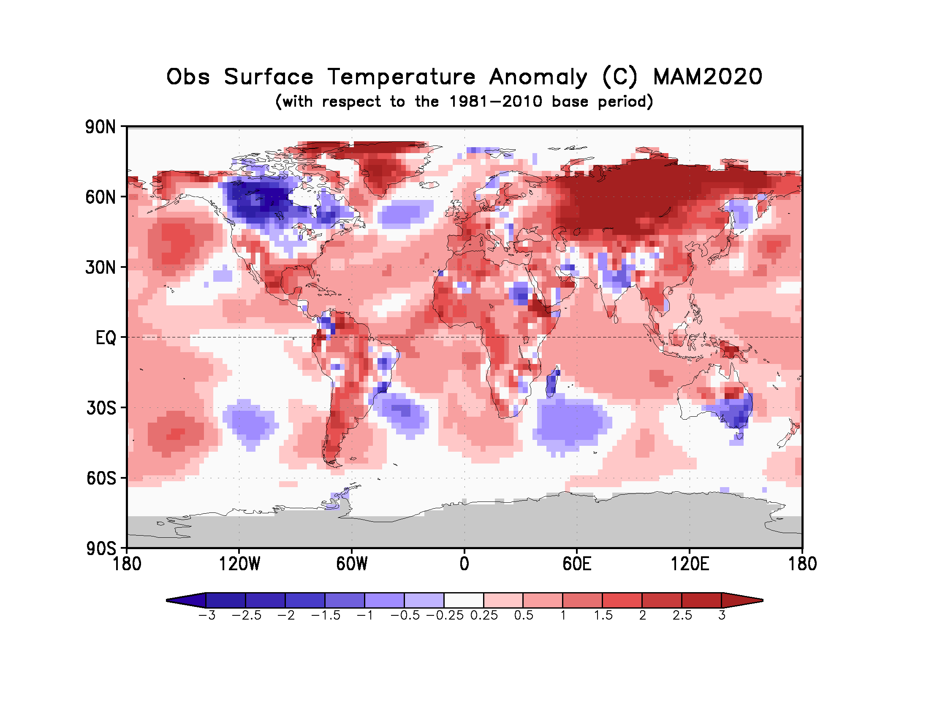

Figure 2. Observed March - May 2020 near-surface temperature anomalies relative to 1981–2010. (Source: U.S. Climate Prediction Center).

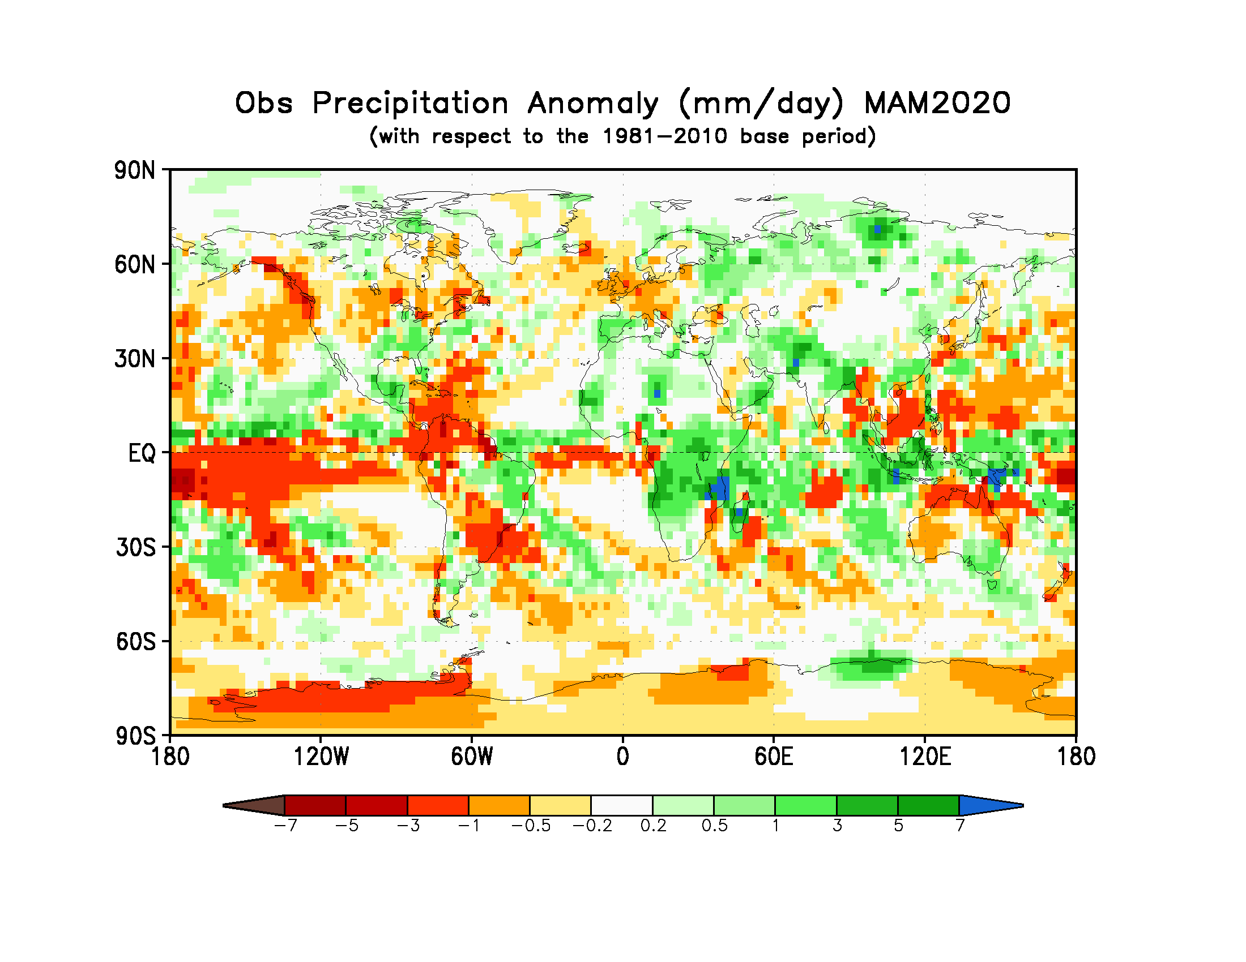
Figure 3. Observed precipitation anomalies for February – April 2020, relative to 1981–2010 base period (top). (Source: U.S. Climate Prediction Center).

