WEATHER CLIMATE WATER

GLOBAL SEASONAL
CLIMATE UPDATE
Pre-Operational Phase
TARGET SEASON: September-October-November 2019

Issued: 23 August 2019
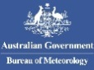

Summary
Observed sea surface temperatures in the east-central topical Pacific were at weak El Niño levels during May-July 2019, but began returning to neutral levels by July. The sea surface temperatures in the Niño 3.4 and Niño 3 regions, both of which are often used to characterize ENSO conditions, are predicted to decrease to approximately 0.1 °C during the September-November 2019 season, and hence, are expected to return back to near-average conditions.
Influences from the expected tendency towards positive sea surface temperature anomalies across sizeable portions of the globe, both in the tropics (except for near-average conditions in the central and eastern Pacific) and extra-tropics, are seen in the temperature forecast for September-November 2019, which leans quite strongly, on average, towards above-normal land temperature, particularly in tropical latitudes. Below-average sea surface temperature is predicted in relatively smaller areas, such as south of Australia, west of Indonesian Archipelago in the eastern Indian Ocean and south of the eastern equatorial Pacific near the coast of South America. Near-average sea surface conditions are predicted in the eastern equatorial Pacific but may still noticeably affect the overlying atmospheric circulation and climate, as they enhance the SST gradients with positive SST anomalies in the western Pacific. A global warming trend also contributes to the sea surface temperature and air temperature forecast, leading to a general prevalence towards a positive tilt in anomalies defined using the climatological base period (1993–2009) centred more than 10 years in the past.
Near-average precipitation conditions are expected in the central and eastern equatorial Pacific, and an enhanced probability for above normal precipitation is expected in the western Pacific and southwestern Indian Ocean extending into equatorial Africa. However, some anomalies do not follow near-average SST conditions in main ENSO region, for example, a tilt of the odds towards below-normal rainfall in northeast South America. Some tilts of the odds are likely associated with sea surface temperature anomalies not directly related to ENSO, for example prediction for a positive phase of the Indian Ocean Dipole and the associated expectation for enhanced probability for below-average precipitation over Australia.

Surface Air Temperature, SON 2019  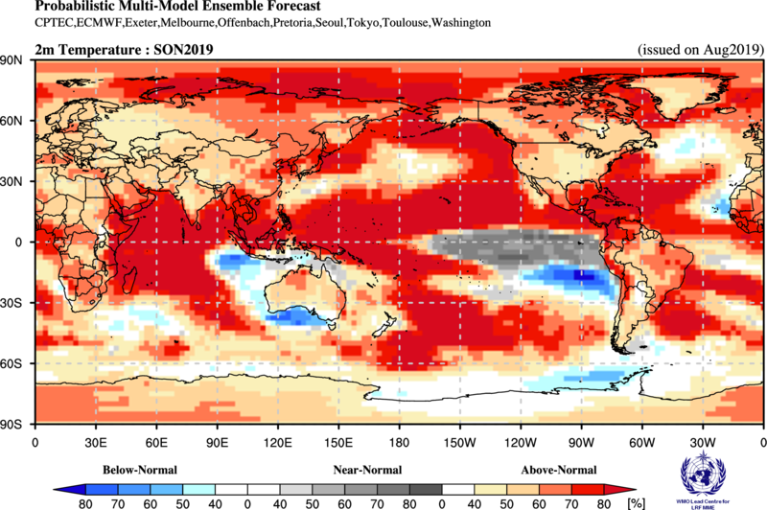 | Precipitation, SON 2019  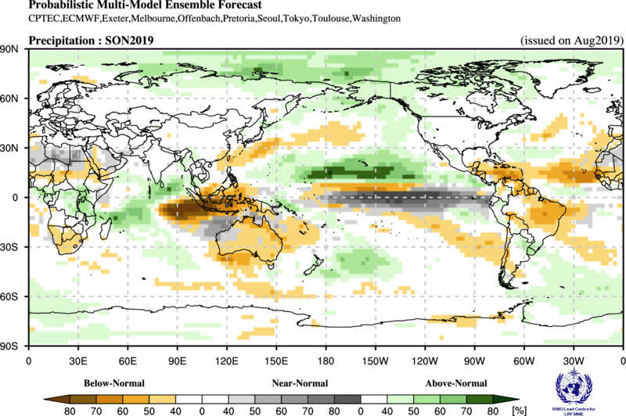

Figure 1. Probabilistic forecasts of surface air temperature and precipitation for the season September-October-Novemebr 2019. The tercile category with the highest forecast probability is indicated by shaded areas. The most likely category for below-normal, above-normal and near-normal is depicted in blue, red and grey shadings respectively for temperature, and orange, green and grey shadings respectively for precipitation. White areas indicate equal chances for all categories in both cases. The baseline period is 1993–2009.

1. Observations: May-June-July 2019
In the following sections, observed temperature and precipitation patterns for the period May-July 2019 are briefly described. For more detailed information about regional and local climate anomalies, the reader is referred to the concerned WMO Regional Climate Centres (RCCs) or RCC Networks, listed in Section 5.

1.1 Large-scale sea surface temperature (SST) indices
Except for the far eastern Pacific region of Niño 1+2, where sea surface temperatures (SST) were below normal, SSTs were above-normal across all other ENSO regions of the Pacific during May-July, more so in the central Pacific (Niño 4) than in the east-central Pacific (Niño 3.4 and Niño 3). The SST conditions showed positive anomalies characteristic of a weak El Niño. SST anomalies in all ENSO regions also declined from their somewhat further above-normal values in February-April 2019, indicating a weakening of El Niño conditions. The Indian Ocean Dipole (IOD) over the period was in a positive phase. The North Tropical Atlantic (NTA) and the South Tropical Atlantic (STA) index showed near-neutral conditions.

Month | Niño 1+2 | Niño 3 | Niño 4 | Niño 3.4 | IOD | NTA | STA
May 2019 | 0.10 | 0.60 | 0.79 | 0.72 | 0.88 | 0.05 | 0.21
Jun 2019 | -0.26 | 0.38 | 0.78 | 0.59 | 0.96 | 0.11 | 0.06
Jul 2019 | -0.28 | 0.06 | 0.92 | 0.41 | 0.80 | 0.08 | 0.02
May 2019-Jun 2019 | -0.15 | 0.35 | 0.83 | 0.57 | 0.88 | 0.08 | 0.10

Table 1. Large-scale oceanic indices (°C). Anomalies are with respect to the 1981–2010 average. (Source: U.S. Climate Prediction Center)

1.2 Observed temperature
Temperature anomalies across the globe continued the trend of warmer-than-normal conditions for the months May-July 2019 (Figure 2, top). Above-normal temperatures dominated the globe, with a few areas of cool anomalies interspersed. The warmest land anomalies occurred over Alaska, South America, Africa, Southern Europe, and southwest, southeast and northeast Asia. Embedded within the general warmth over land, regions of below-normal land temperature were located over central North America and southern Indonesian Archipelago.
Most oceanic regions, except for small areas of cooler-than-normal temperatures southwest and northwest of Australia, the Southern Hemisphere oceans west and south of South America, and the eastern tropical Atlantic, had positive temperature anomalies. SSTs in the equatorial Pacific indicated weak El Niño conditions in the east-central equatorial Pacific. SST anomalies throughout the extratropical North Pacific Ocean were generally positive.
Consistent with the seasonal mean anomalies, warm extremes dominated (Figure 2, bottom panel). Warm extremes (exceeding temperatures observed during 1981–2010) occurred over central and southern Africa and over some regions of equatorial South America. Much cooler than normal temperatures (in lowest decile) were found over part of northern North America and over the oceanic region southwest and northwest of Australia.

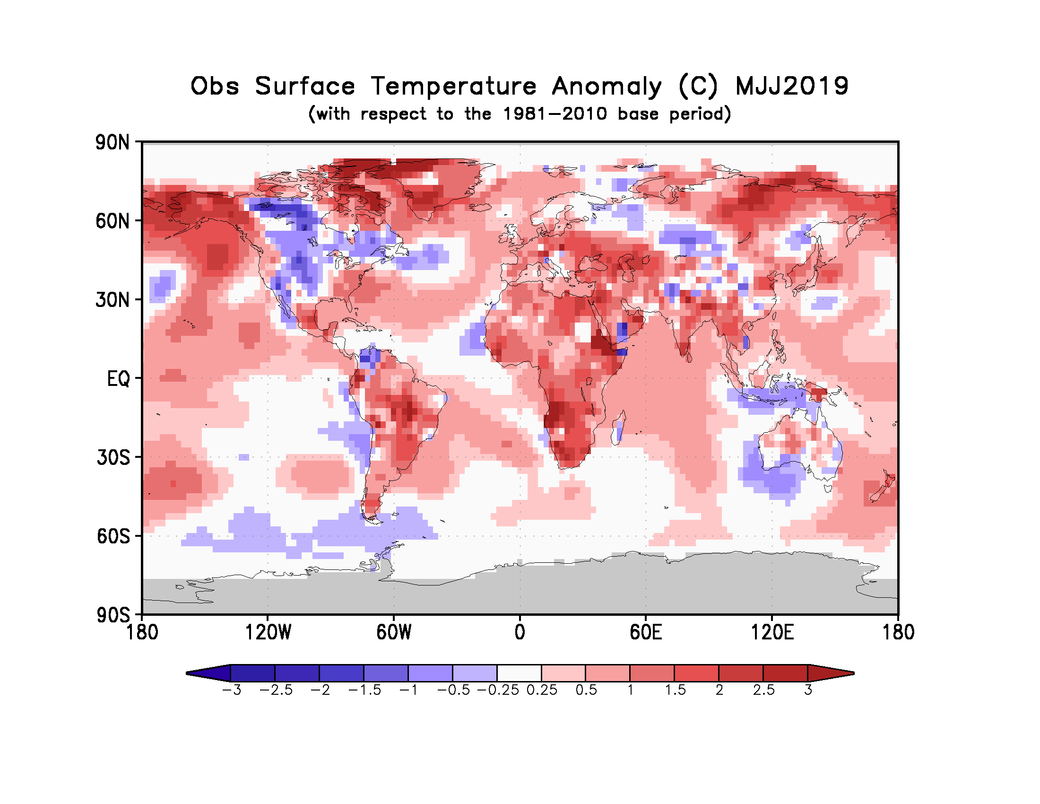
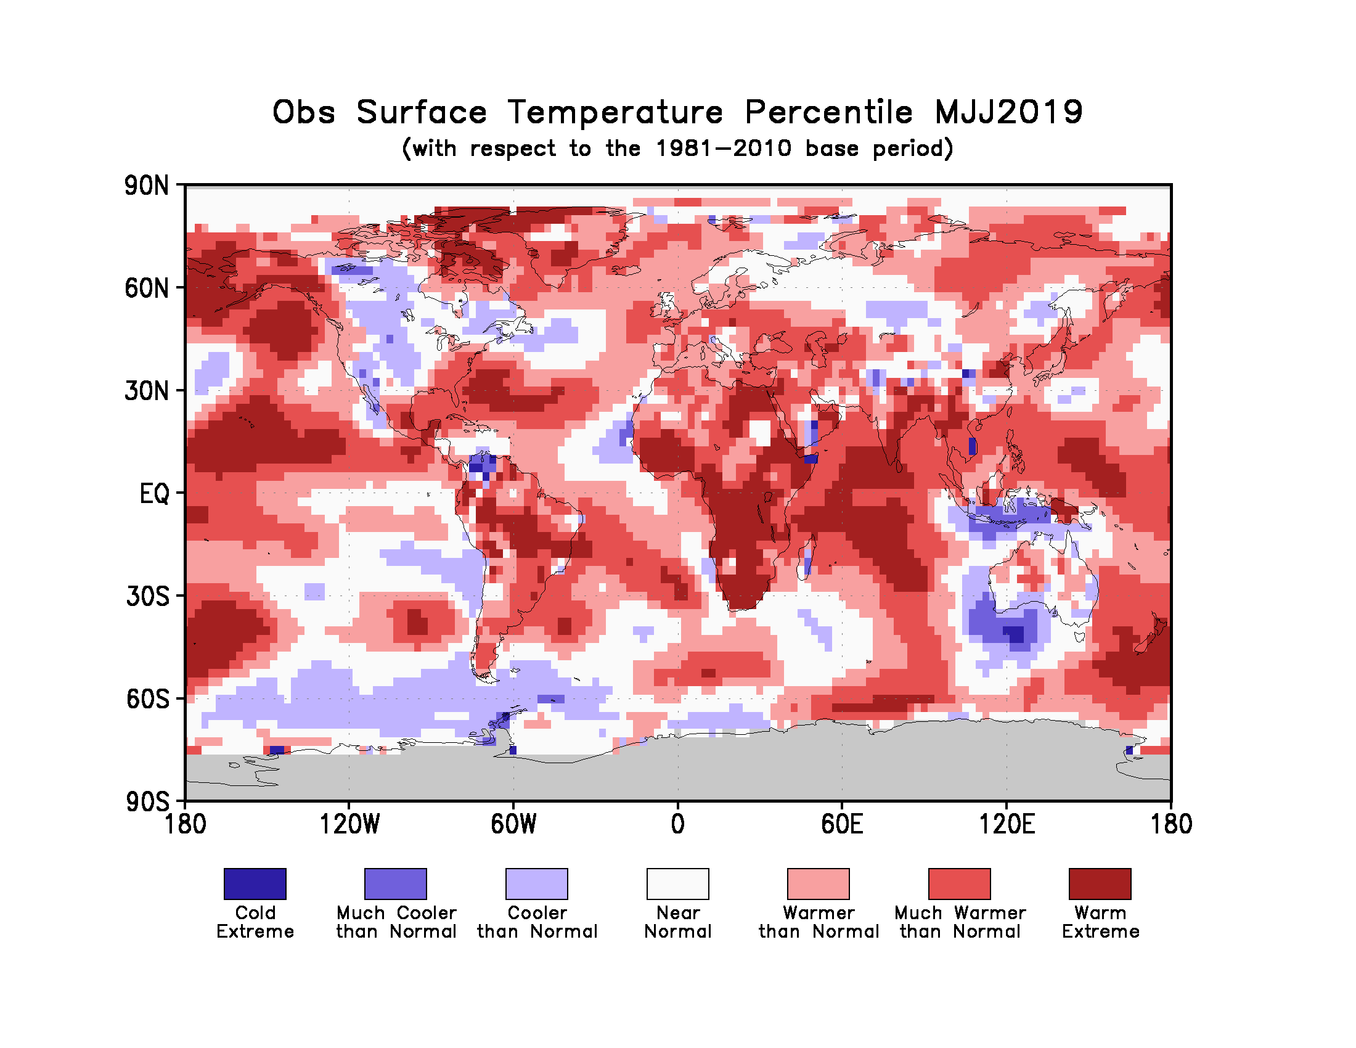

Figure 2. Observed May-July 2019 near-surface temperature anomalies relative to 1981–2010 (top). The Cooler than Normal, Near Normal, and Warmer than Normal shadings on the percentile map (bottom) indicate that seasonal mean anomalies were in the bottom, middle, and upper tercile of the 1981–2010 distribution, respectively. Regions with anomalies in the lowest and highest decile (or 10%) of the distribution are marked as Much Cooler than Normal and Much Warmer than Normal, respectively. The Cold Extreme and Warm Extreme shadings indicate that the anomalies exceeded the coldest and warmest temperature values of the 1981–2010 period for the season. Grey shading indicates areas where observational analysis was not available. (Source: U.S. Climate Prediction Center).

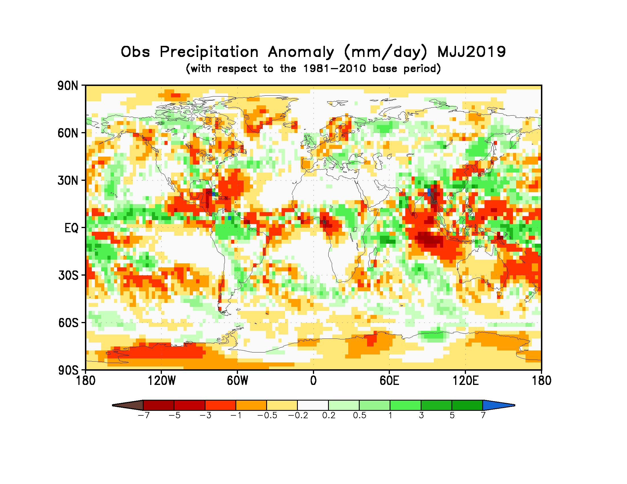
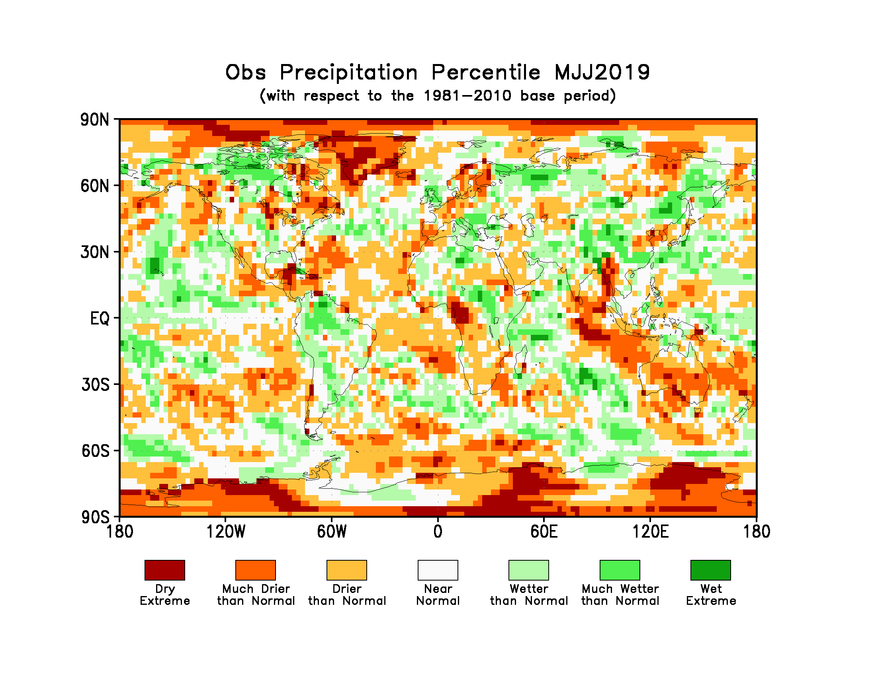
Figure 3. Observed precipitation anomalies for May-July 2019, relative to 1981–2010 base period (top). The Drier than Normal, Near Normal and Wetter than Normal shadings on the percentile map (bottom) indicate that seasonal mean anomalies were in the bottom, middle, and upper tercile of the 1981–2010 distribution, respectively. Regions with anomalies in the lowest and highest decile (or 10%) of the distribution are marked as Much Drier than Normal and Much Wetter than Normal, respectively. The Dry Extreme and Wet Extreme shadings indicate that the anomalies exceeded the driest and wettest values of the 1981–2010 period for the season.
(Source: U.S. Climate Prediction Center).

1.3 Observed precipitation
For May-July 2019 above-normal precipitation anomalies were located west of 120ºW over the warm SSTs associated with weak El Niño conditions in the equatorial Pacific. Farther west, over the western Indonesian Archipelago and in the Indian Ocean Northwest of Australia, these positive anomalies were flanked by negative precipitation anomalies. Negative precipitation anomalies also occurred over the western parts of central Africa (a region that also experienced above-normal temperatures). Over South America precipitation anomalies were generally positive. A band of negative precipitation anomalies extended from eastern Pacific into Central America and the Caribbean. Precipitation anomalies were generally negative over Australia with larger negative anomalies over eastern Australia. No systematic regions with dry or wet extremes (precipitation below or above that observed during 1981-2010) over land occurred, with the exception of a few small isolated pockets that were observed such as in west-central Africa or Greenland. In general, the global precipitation anomaly pattern did not exhibit large-scale spatial coherence because the El Niño conditions were weak.

2. Potential evolution of the state of the climate over the next three months (September-October-November 2019)

2.1 Large-scale SST-based indices, September-October-November 2019
Month | Nino 1+2 | Nino 3 | Nino 4 | Nino3.4 | IOD | NTA | STA
September2019 | -0.36 ± 0.18 | -0.16 ± 0.29 | 0.41 ± 0.28 | 0.01 ± 0.42 | 0.67 ± 0.47 | 0.21 ± 0.15 | 0.23 ± 0.24
October2019 | -0.23 ± 0.18 | -0.08 ± 0.34 | 0.38 ± 0.23 | 0.06 ± 0.40 | 0.56 ± 0.29 | 0.24 ± 0.14 | 0.22 ± 0.17
November2019 | -0.10 ± 0.25 | -0.01 ± 0.39 | 0.36 ± 0.23 | 0.12 ± 0.44 | 0.33 ± 0.17 | 0.24 ± 0.15 | 0.24 ± 0.12
September-  November2019 | -0.23 ± 0.22 | -0.08 ± 0.33 | 0.38 ± 0.24 | 0.06 ± 0.41 | 0.52 ± 0.35 | 0.23 ± 0.14 | 0.23 ± 0.18

Table 2: Multi-model forecasts for oceanic indices (℃), with standard deviation. Values are the equal-member-weighting average of those derived, using each GPC models own hindcast climate mean, from the 13 GPCs supplying SST forecasts (GPC Beijing, CPTEC, ECMWF, Exeter, Melbourne, Montreal, Moscow, Offenbach, Pretoria, Seoul, Tokyo, Toulouse, Washington). The standard deviation is calculated on all ensemble members, except for GPC Toulouse (GPC Toulouse provides only ensemble mean anomaly). The latitude/longitude bounds of the regions are given in the supplementary information section.

Observed sea surface temperatures in the east-central topical Pacific were at weak El Niño levels during May-July 2019. The sea surface temperatures in the Niño 3.4 and Niño 3 regions, both of which are often used to characterize ENSO conditions, are predicted to decrease to approximately 0.1 °C during the September-November 2019 season, and hence, are expected to return back to near-average conditions. Farther west in the Niño 4 region, the sea surface temperature is predicted to remain above-average with a value of approximately 0.4 °C. The IOD prediction is for above-average, but gradually weakening, conditions during September-November 2019. The northern equatorial Atlantic SST (NTA) is predicted to be near-average during the season, and the southern equatorial Atlantic SST (STA) is also predicted to be near-average.

2.2 Predicted temperature, September-October-November 2019
For information on the construction of the multi-model forecast maps refer to the supplementary information section. (Note: Maps indicating forecast consistency among GPC models are available in the supplementary information).

Figure 4. Probabilistic forecasts of surface air temperature for September-November 2019. The tercile category with the highest forecast probability is indicated by shaded areas. The most likely category for below-normal, above-normal and near-normal is depicted in blue, red and grey shadings respectively. White areas indicate equal chances for all categories in both cases. The baseline period is 1993–2009.
Influences from the expected tendency towards positive sea surface temperature anomalies across sizeable portions of the globe, both in the tropics (except for near-average conditions in the central and eastern Pacific) and extra-tropics, are seen in the temperature forecast for September-November 2019, which leans quite strongly, on average, towards above-normal land temperature, particularly in tropical latitudes. Below-average sea surface temperature is predicted in relatively smaller areas, such as south of Australia, west of Indonesian Archipelago in the eastern Indian Ocean and south of the eastern equatorial Pacific near the coast of South America. Near-average sea surface conditions are predicted in the eastern equatorial Pacific but may still noticeably affect the overlying atmospheric circulation and climate, as they enhance the SST gradients with positive SST anomalies in the western Pacific. A global warming trend also contributes to the sea surface temperature and air temperature forecast, leading to a general prevalence towards a positive tilt in anomalies defined using the climatological base period (1993–2009) centred more than 10 years in the past.
RA I (Africa): An enhanced probability for above-normal temperature is predicted over virtually all of Africa, with strong-to-moderate model-to-model consistency. The strongest tilt of the odds towards warmer temperature is predicted over the tropical, western and southern portions of Africa; relatively weaker tilts of the odds are predicted over northern Africa. It is noted that above-normal temperatures would lead to a continuation of generally above-normal temperatures observed in equatorial and southern Africa during May-July 2019.
RA II (Asia): Weakly to moderately enhanced probabilities for above-normal temperature are predicted over most of central Asia and the northern Middle East. A stronger tendency towards above-normal temperature is forecast for northeast and eastern Asia and southern Middle east, where model consistency is also strong. The strongest probabilities for above-normal are in southern, and especially southeast, Asia. Much of the region predicted likely to be above-normal was also observed to be above-normal during May-July 2019, with the exception of a portion of central Asia where near- and below-normal temperatures were observed.
RA III (South America): Enhanced probabilities for above-normal temperature are predicted in most of South America, with a stronger tilt in the probabilities towards warmth in the northern and eastern portions as well as much of the immediate west coastal area. A tilt of the odds towards warm is lacking over a small region in the central interior of the continent. The spatial structure of model consistency is similar to the tilt in probabilities. Observed temperatures during May-July 2019 were also generally above-normal with some regions coinciding with an above-normal tendency in the prediction, particularly in northern and eastern South America.
RA IV (North America, Central America and the Caribbean): Enhanced probabilities for above-normal temperature are strongly predicted in northernmost North America, in the Caribbean and all of Central America. Moderately enhanced probabilities for above-normal temperature are predicted for the interior regions of the continent with weakest probabilities in the eastern part of the continent. Model consistency is generally strong over the entirety of North America, the Caribbean and Central America. Much of the region with an above-normal prediction in north and central North America was below-average during May-July 2019, marking a reversal from the May-July 2019 tendencies.
RA V (Southwest Pacific): An enhanced probability for above-normal temperature is predicted in much of the Southwest Pacific region, including the eastern and western Indonesian archipelago, Australia, but not over New Zealand and in parts of the southwest Pacific islands where there is no forecast signal. Model consistency for above-normal is strong in most of these areas. The only regions of weakly enhanced probabilities for below normal temperature are over southern Indonesian archipelago. For much of the region, the May-July 2019 observations matched the above-normal forecast, with the exception of small portions of Australia and also the southern portion of the Indonesian archipelago, where observations matched the below-normal forecast. The prediction for warmth is consistent with the prediction for above-average SST conditions in the western Pacific.
RA VI (Europe): A weakly to moderately enhanced probability for above-normal temperature is predicted in virtually all of Europe and Greenland. Consistency among individual models for the above-normal prediction is moderate-to-strong, but less strong in central Greenland. This prediction for above-normal temperature follows up on generally above-normal temperatures observed over most of mainland Europe but is opposite to the observed near-avergae and below-normal temperature over northern and northwest Europe during May-July 2019.

2.3 Predicted precipitation, September-October-November 2019

Figure 5. Probabilistic forecasts of precipitation for the season June-July-August 2019. The tercile category with the highest forecast probability is indicated by shaded areas. The most likely category for below-normal, above-normal and near-normal is depicted in orange, green and grey shadings respectively. White areas indicate equal chances for all categories in both cases.
The baseline period is 1993–2009.

Near-average SST conditions are expected during the September-November 2019 season in the central and eastern equatorial Pacific with warmer SST conditions in the western Pacific and western Indian Ocean, and some of the predicted large-scale seasonal precipitation anomalies are consistent with this spatial pattern. Near-average precipitation conditions are expected in the central and eastern equatorial Pacific, and an enhanced probability for above-normal precipitation is expected in the western Pacific and southwestern Indian Ocean extending into equatorial Africa. However, some anomalies do not follow near-average SST conditions in main ENSO region, for example, a tilt of the odds towards below-normal rainfall in northeast South America. Some tilts of the odds are likely associated with sea surface temperature anomalies not directly related to ENSO, for example, the prediction for a positive phase of the Indian Ocean Dipole and the associated expectation for enhanced probability for below-average precipitation over Australia.
RA I (Africa): Weakly enhanced probabilities for below-normal precipitation are predicted in the Sahel region of Africa, stretching from western Africa, where the signal is stronger and model consistency is strongest, eastward to just north of the Greater Horn. A weak tilt of the odds towards below-normal is also predicted in southern Africa with moderate consistency among models. Weakly enhanced probabilities for above-normal precipitation are predicted in part of central Africa, with moderate model consistency.
RA II (Asia): Weakly enhanced probabilities for above-normal precipitation are predicted in parts of northern Asia and western parts of southeast Asia, with moderate model consistency. Elsewhere over Asia no discernible predictable signal is found.
RA III (South America): An enhanced probability for below-normal precipitation is predicted over a large part of the northern and eastern parts of equatorial South America, both with moderate to strong model consistency. The forecast is also for the below-normal conditions over the extreme southern regions of the South America with moderate consistency among models. A weak tilt for above-normal precipitation is predicted over part of southeast South America with a strong consistency among models.
RA IV (North America, Central America and the Caribbean): An enhanced probability for below-normal precipitation is predicted in Central America and most of the Caribbean. A weakly enhanced probability of above-normal precipitation is forecast in the northern and north-western coast of North America. Both of the above-mentioned forecast regions have moderately strong model consistency. The forecast for below-normal in Central America and the Caribbean generally indicates a continuation of drier conditions observed in May-July 2019 observations.
RA V (Southwest Pacific): Enhanced probabilities for below-normal precipitation are predicted for the Indonesia archipelago, Australia, and all except for the northernmost southwest Pacific islands. These regions all show moderate to strong model consistency. A tilt of the odds towards above-normal is forecast for southern New Zealand with moderate model consistency. The forecast for below-normal over Indonesian Archipelago and Australia matches the May-July 2019 below normal precipitation in observations.
RA VI (Europe): Except over northern Greenland where tilt in probability is for above-averge precipitation, over most of the Europe and southern Greenland there is no distinct signal that is forecast by the models. The model consistency for above normal precipitation over Northern Greenland is moderate.

3. Latest updates for monitoring and prediction information
Each month, the latest updates for the real-time monitoring and seasonal mean predictions included in GSCU can be found at:
Monitoring:
https://ftp.cpc.ncep.noaa.gov/mingyue/GSCUWMO/
Predictions:
https://www.wmolc.org/modules/data/plot/autograds4/download_PMME.php?filename=wmo/WMOLC_T2M.gif
https://www.wmolc.org/modules/data/plot/autograds4/download_PMME.php?filename=wmo/WMOLC_PREC.gif

4. How to use the Global Seasonal Climate Update
The GSCU is intended as guidance for RCCs, Regional Climate Outlook Forums (RCOFs) and National Meteorological and Hydrological Services (NMHSs). It does not constitute an official forecast for any region or nation. Seasonal outlooks for any region or nation should be obtained from the relevant RCCs (see below for contact details) or NMHS.
Seasonal forecasts are probabilistic in nature. Although the text and figures used in the GSCU highlight the tercile categories that is predicted with the highest probability, it is important to recognize that the other tercile categories may also have substantial (though lower) probability.
The geographical areas occupied by the forecast signals should not be considered precise. Similarly, signals with small spatial extent may be unreliable.
The skill of seasonal forecasts is substantially lower than that of weather timescales and skill may vary considerably with region and season. It is important to view the forecast maps together with the skill maps provided in the supplementary appendices.
For reference, the six WMO Regional Associations domains are depicted in the figure below.
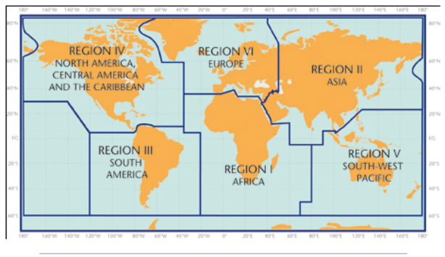

5. Designated and developing WMO Regional Climate Centres and Regional Climate Centre Networks
- RA I: http://www.wmo.int/pages/prog/wcp/wcasp/RCC-Africa.html
- RA II: http://www.wmo.int/pages/prog/wcp/wcasp/RCC-Asia.html
- RA III: http://www.wmo.int/pages/prog/wcp/wcasp/RCC-SouthAmerica.html
- RA IV: http://www.wmo.int/pages/prog/wcp/wcasp/RCC-NorthAmerica.html
- RA V: http://www.wmo.int/pages/prog/wcp/wcasp/RCC-SouthwestPacific.html
- RA VI: http://www.wmo.int/pages/prog/wcp/wcasp/RCC-Europe.html

6. Resources
Sources for the graphics used in the GSCU:
- The WMO Lead Centre for Long-Range Forecast Multi-Model Ensemble (LC-LRFMME): http://www.wmolc.org
- WMO portal to the Global Producing Centres for Long-range Forecasts (GPCs-LRF): http://www.wmo.int/pages/prog/wcp/wcasp/clips/producers_forecasts.html
- WMO GSCU portal
http://www.wmo.int/pages/prog/wcp/wcasp/LC-LRFMME/index.php
- WMO portal for Regional Climate Outlook Forums (RCOFs):
https://public.wmo.int/en/our-mandate/climate/regional-climate-outlook-products
- International Research Institute for Climate and Society (IRI):
http://portal.iri.columbia.edu/portal/server.pt
- NOAA Climate Prediction Centre (CPC):
http://www.cpc.noaa.gov

7. Acknowledgements
This Global Seasonal Climate Update was jointly developed by the WMO Commission for Climatology and Commission for Basic Systems with contributions from:
- WMO Lead Centre for Long-Range Forecast Multi-Model Ensemble (LC-LRFMME), Korea Meteorological Administration, NOAA National Centers for Environmental Prediction
- WMO Global Producing Centres for Long-Range Forecast (GPCs-LRF): GPC-Beijing (China Meteorological Administration), GPC-CPTEC (Center for Weather and Climate Studies, Brazil), GPC-ECMWF (European Center for Medium-Range Forecast), GPC-Exeter (UK Met Office),GPC- Melbourne (Bureau of Meteorology), GPC-Montreal (Meteorological Services of Canada), GPC-Moscow (Hydro meteorological Center of Russia), GPC-Offenbach Deutscher Wetterdienst), GPC-Pretoria (South African Weather Services), GPC-Seoul (Korea Meteorological Administration), GPC-Tokyo (Japan Meteorological Administration), GPC-Toulouse (Météo-France), GPC-Washington (National Centers for Environmental Prediction)
- International Research Institute for Climate and Society (IRI)

File with supplementary information can be downloaded from https://ftp.cpc.ncep.noaa.gov/mingyue/GSCUWMO/Supplementary/GSCU_SON2019_supplementary_info_LC-LRFMME.docx

